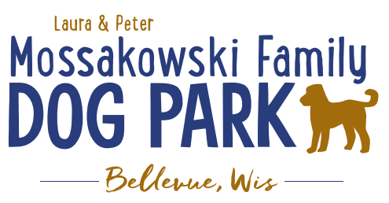
Laura and Peter Mossakowski Family Dog Park, LTD Committee Meeting

Date & Location: December 6th, 2017 @ 9:15am at Laura Mossakowski LLC (2555 Continental Dr.; Green Bay, 54311)

Meeting Began:

In attendance:

Secretary Report:
Approval of October 25th minutes:

Treasurers Report:
Current Balance:
Outstanding Bills:
Incoming Donations:

Community Fundraising:
Grant Writing – UPDATE on UWGB Intern – likely not having one this semester but open for next semester
Internship description sent out to search for a UWGB student with focus on Grant-writing but also including some marketing – Title: Grant Writing and Marketing Coordinator Intern

Give Big Green Bay Award Submitted – no word back yet

100 Women Who Care Event

Branded Items with Dog Park Logo for Fundraising
Can items be sold anywhere other than at the events? Available on website? Available at any location?

TAP grants from DOT – application for grant needs to come from the village of Bellevue or Allouez (applications start end of October) – anything further needed? – conversation with both Bellevue and Allouez to be the sponsor of the application

Old Business:
K9 Karnval planning to start in early 2018 – Coordinator and Co-coordinator roles to lead event

K9 Karnival – May 12th, 2018 from 10am -2pm - Josten Park vs Dog Park (Ideally at the Dog Park but primary hold up is parking if it is at the Dog Park, looking to get permission from nearby businesses for parking help) – draft letter to send to the area businesses to ask permission to use some lots
Consider seeking a shuttle service to help transport as well – thoughts?

Phase II Planning (running topic) – need a closer idea / update estimates for items for future planning to help decide what will actually be in Phase II but initial thoughts include:
Water/sewer – cost to run it to park needed
Splash Pad – timed shut-off and button for turning on
Agility course/equipment – potentially donated
Water Bubbler with human and dog faucet – cost of running water needed
Further Shade Structures – second one donated in large dog area, look for further options in small dog area
Other – based on available funding, estimates, and available grants

Ambassador Lanyards for Park Volunteers and / or Ambassadors – when roles are defined more clearly both could have lanyards as well as perhaps mark them accordingly, title to be altered to help clarify?

Next Meeting Date: _____________________ at Laura Mossakowski LLC (2555 Continental Dr.; Green Bay, 54311)

Construction & Maintenance Updates:
Spring Work Day Plan – need to stain, fertilize, plant around the fencing, mud-prone areas,
Fertilizer would need to be pet safe or a plan to make it a safe time to do it – get Lizer’s input/feedback
May need post hole digger to dig in gravel area for plants
In spring look to re-seed areas that are sparse

What should be looked at being done before winter?
Purchase a few shovels for keeping at the gates for the winter? – any donations offered on FB?

New Business:
Forever Friends – tabled from Oct. Meeting

Park Ambassador Vests – tabled from Oct. Meeting

Recent Park Concerns/Problems -

Outline Memorial Donation Options – benches, another hydrant, parts of the park (structures), large rocks

Letter requesting parking help – Lizer, Packerland KC, Hemophilia Center,

Meeting Adjourned:

