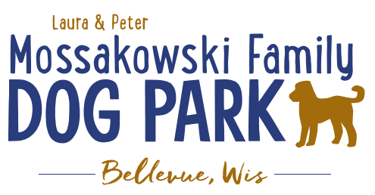
Laura and Peter Mossakowski Family Dog Park, LTD Committee Meeting

Date & Location: October 25th, 2017 @ 9:15am at Laura Mossakowski LLC (2555 Continental Dr.; Green Bay, 54311)

Meeting Began: 9:20pm

In attendance: Laura Mossakowski, Paul Theys, Jennie Wertel, Mark Schuster

Secretary Report:
Approval of September 13th minutes: Paul, Laura

Treasurers Report:
Current Balance: $9,624.95
Outstanding Bills: $6500 left for Lizer
Incoming Donations: $100 donation in
(From Sandy: The Trick Treat Trail went well. About 1300 kids came, it was busy!
Sold $63.25 at our bake sale. Note: Puppy Chow snack mix is a huge hit!
$23.44 in donations at Oak View (1 basket raffle & donations))

Community Fundraising:
Grant Writing – UPDATE on UWGB Intern
Internship description sent out to search for a UWGB student with focus on Grant-writing but also including some marketing – Title: Grant Writing and Marketing Coordinator Intern

Packers Give Back Award Nominations Submitted – not chosen this year

Give Big Green Bay Award Submitted – no word back yet

Branded Items with Dog Park Logo for Fundraising
Can items be sold anywhere other than at the events? Available on website? Available at any location?

TAP grants from DOT – application for grant needs to come from the village of Bellevue or Allouez (applications start end of October) – anything further needed? – conversation with both Bellevue and Allouez to be the sponsor of the application

Old Business:
K9 Karnval planning to start in early 2018 – looking to fill role for a Co-coordinator

K9 Karnival – May 12th, 2018 from 10am -2pm - Josten Park vs Dog Park (Ideally at the Dog Park but primary hold up is parking if it is at the Dog Park, looking to get permission from nearby businesses for parking help) – draft letter to send to the area businesses to ask permission to use some lots
Consider seeking a shuttle service to help transport as well??

Phase II Planning – need a closer idea / update estimates for items for future planning to help decide what will actually be in Phase II but initial thoughts include:
Water/sewer – cost to run it to park needed
Splash Pad – timed shut-off and button for turning on
Agility course/equipment – potentially donated
Water Bubbler with human and dog faucet
Further Shade Structures – another one getting donated (should be in this week)
Other – based on available funding, estimates, and available grants

Ambassador Lanyards for Park Volunteers and / or Ambassadors – when roles are defined more clearly both could have lanyards as well as perhaps mark them accordingly, title to be altered to help clarify?

Next Meeting Date: Wednesday, Dec. 6th @ 9:15am at Laura Mossakowski LLC (2555 Continental Dr.; Green Bay, 54311)

Construction & Maintenance Updates:
Any further work days needed? – need to stain, fertilize, plant around the fencing, mud-prone areas,
Fertilizer would need to be pet safe or a plan to make it a safe time to do it – get Lizer’s input/feedback
May need post hole digger to dig in gravel area for plants
In spring look to re-seed areas that are sparse

What should be looked at being done before winter?
Purchase a few shovels for keeping at the gates for the winter? – ask for donations on FB

Fence escape addressed – no new concerns mentioned

Signs to be made for making safety concern calls accessible within the park – THANK YOU to Forever Friends for helping out with these!

New Business:
Forever Friends – tabled until Dec. meeting

Park Ambassador Vests – tabled until Dec. meeting

Park Ambassador job description/clarification – there to promote positive culture and help to explain park rules, etc., communicating with visitors, answer questions,

Recent Park Concerns/Problems - need clarification on ambassador role

Outline Memorial Donation Options – benches, another hydrant, parts of the park (structures), large rocks

Meeting Adjourned: 10:30am

