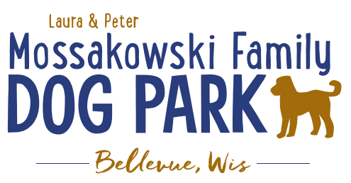
Laura and Peter Mossakowski Family Dog Park, LTD Committee Meeting

Date & Location: January 3rd, @ 9:15am at Laura Mossakowski LLC (2555 Continental Dr.; Green Bay, 54311)

Meeting Began:

In attendance:

Secretary Report:
Approval of December 2017 minutes:

Treasurers Report:
Current Balance:
Outstanding Bills:
Incoming Donations:

Community Fundraising:
Grant Writing – UPDATE on UWGB Intern – No further contacts from students re: opportunity at this time

Give Big Green Bay Award Submitted – not approved this year

100 Women Who Care Event – Feb. 7th Video/Pictures needed for 15 min presentation for a donation (please continue to gather pictures that may be helpful)

Dog Park Branded items for sale at upcoming events

Old Business:
K9 Karnval planning to start in early 2018 – Coordinator and Co-coordinator roles to lead event
Adam will be the go-to contact for the Parks communications until Stephanie is back

K9 Karnival – May 12th, 2018 from 10am -2pm - Josten Park vs Dog Park – Village doesn’t support having it at the Dog Park and keeping it at Josten Park again so approval requested to offer free day pass for paid admission to encourage visitors

Phase II+ Planning (running topic) – need a closer idea / update estimates for items for future planning to help decide what will actually be in Phase II but initial thoughts include:
Water/sewer – cost to run it to park needed
Water Bubbler with human and dog faucet/washer – cost of running water needed
Est: $50-60,000

Trail-head Building and Area
Est: $300,000

Bridge cost
Est: $300,000

Entrance Structures and Picnic Shelter in Park
Est: $40,000

Kayak Launch
Est: $8,000 – may have some options for grants

Additional Parking & Lighting Option
Est: $25-30,000

Agility course/equipment – potentially donated

Further Shade Structures – for further options in small dog area

Other – based on available funding, estimates, and available grants

Ambassador Lanyards for Park Ambassadors Printed

Next Meeting Date: _______________ @ 9:15am at Laura Mossakowski LLC (2555 Continental Dr.; Green Bay, 54311)

Construction & Maintenance Updates:
Spring Work Day Plan – need to stain, fertilize, plant around the fencing, mud-prone areas,
Fertilizer would need to be pet safe or a plan to make it a safe time to do it – get Lizer’s input/feedback
May need post hole digger to dig in gravel area for plants
In spring look to re-seed areas that are sparse

New Business:
Motion to have Toni added to board approved in December 2017 – Official title and starting date

Outline Memorial Donation Options – benches ($2,500 minimum), another hydrant ($2,500 minimum), parts of the park (structures), large rocks ($500 based on donation of rock), have list of tangible and intangible items listed and outlined

Meeting Adjourned:

