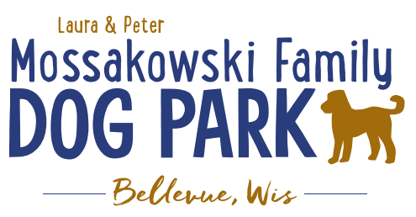
Board Meeting Minutes:
Meeting rescheduled from bylaws outline date to be today; January 3, 2018 @ 10:30am

Meeting Began: 10:30am

Attendance: Laura Mossakowski, Sandy Kemper, Paul Theys, Jennie Wertel, Toni McBride

Officially adding Toni McBride to the Board as the Laura and Peter Mossakowski Family Dog Park Director of Community Relations – WELCOME Toni!!

Officer Re-election
Laura Mossakowski – President
Sandy Kemper – Vice President
Paul Theys – Treasurer
Jennie Wertel – Secretary
Toni McBride – Director of Community Relations

Review of 2017 Meeting Minutes including prior Jan. 3, 2018 meeting

2018 Focus:
Phase II Planning – priority focus on water and sewer for the park as well as natural equipment/structures

K9 Karnival and Fundraising Planning – Looking to hold event at the dog park in the future but this year Josten Park is preferred by the Village
2018 K9 Karnival passes will get a ticket for a free day pass at the park to be used by June 15th and a raffle prize to be offered for those passes redeemed

Committee Building – continue to build on the size of the committee to be able to continue to offer more dog friendly events and opportunities such as Yoga in the Park, etc.

Per the agreement with the Village the Committee is responsible for 75% of the maintenance where the Village is now responsible for 25% for the 2018 calendar year. The agreement will continue to mature to reach the 2021 goal where 100% of the cost of maintenance will be taken over by the Village.

Meeting Adjourned: 11:00am

