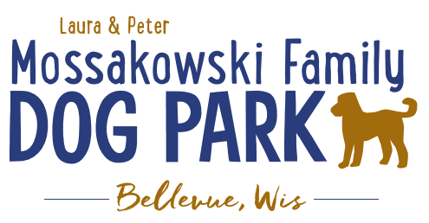
Laura and Peter Mossakowski Family Dog Park, LTD Committee Meeting

Date & Location: May 9th, 2018 @ 9:15am at Laura Mossakowski LLC (2555 Continental Dr.; Green Bay, 54311)

Meeting Began:

In attendance:

Secretary Report:
Approval of April 2018 minutes:

Treasurers Report:
Current Balance: $
Outstanding Bills:
Incoming Donations:

Community Fundraising:
Grant Writing – UPDATE on Interns – Sami has joined us and is starting to submit some grants and a UWGB student, Jess is also looking to get involved

K9 Karnival is THIS WEEK

Dog Park Branded items for sale online

Old Business:
K9 Karnval Planning (running topic) – Coordinator and Co-coordinator roles to lead event
Date: May 12th, 2018 10am – 2pm (Volunteers from 8:30am – ~3:00pm)
Coordinator/Co-coordinator Roles: Sandy Kemper & Charity Schneider

Options for having a “package” with a coffee mug purchase or similar with the ticket – Through Café Press, purchase item and bring receipt for the K9 Karnival admission and pass. Items added to Café Press.

Previous booth/vendor list reviewed and will get letters inviting them to join us again. Add in other suggestions to build on the list.

Volunteer openings

Key volunteers at the event to wear some type of visible matching attire to help guide. (Vests, etc.)
Updates: Vests for key volunteers

Will event be rain or shine?

Phase II+ Planning (running topic) – need a closer idea / update estimates for items for future planning to help decide what will actually be in Phase II but initial thoughts include:
*Water Bubbler with human and dog faucet/washer – cost of running water needed
Est: $40-50,000 (based on where hook-up allows)
Proposed site and looking to get bids
Permits being sought over next month or so

Trail-head Building and Area
Est: $300,000

Bridge cost
Est: $300,000

Entrance Structures and Picnic Shelter in Park
Est: $40,000

Kayak Launch
Est: $8,000 – may have some options for grants

Additional Parking & Lighting Option
Est: $25-30,000

*Agility course/equipment – potentially donated and seek rocks/logs and natural items (Some logs for natural structures donated from the Village)

Further Shade Structures – for further options in small dog area

Other – based on available funding, estimates, and available grants

Options for some shade structures for entrance areas to be built from Costco, etc.

*Items to focus on for 2018

Next Meeting Dates: May 9th @ 9:15am at Laura Mossakowski LLC (2555 Continental Dr.; Green Bay, 54311)

Construction & Maintenance Updates:
Spring Work Day Plan (running topic) – need to stain, fertilize, plant around the fencing, mud-prone areas,
Fertilizer would need to be pet safe or a plan to make it a safe time to do it – get Lizer’s input/feedback
May need post hole digger to dig in gravel area for plants
In spring look to re-seed areas that are sparse – Lizer to help with partitioning areas and re-seeding
Stain rest of the posts
Concrete posts to replace the wooden posts
Limestone screenings to replace some of the pea-gravel areas that aren’t holding up well
Gravel added to path? - Limestone screenings so it packs better and acts as disinfectant for shoes
Little Free Library Station – needs post (station already donated) – needs park commission approval
Set out the logs and other items from Village
Tentative Date: June 9th, 2018 - 9am – 12pm – Lunch provided
Tractor needed to dig post holes

Storage Options for Waste Station Bags on site?

Meeting Adjourned:

