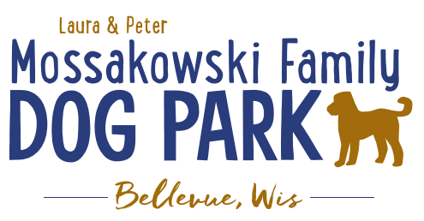
Laura and Peter Mossakowski Family Dog Park, LTD Committee Meeting

Date & Location: June 20th, 2018 @ 9:15am at Laura Mossakowski LLC (2555 Continental Dr.; Green Bay, 54311)

Meeting Began: 9:25am

In attendance: Paul Theys, Laura Mossakowski, Charity Schneider, Sami Van Dreese, Mark Schuster, Jess Danen, Cody (intern for Bellevue), Adam (Parks and Rec Director??)

Secretary Report:
Approval of May 2018 minutes: Not enough board members in attendance to approve; will approve at next meeting.

Treasurers Report:
Current Balance: $14,185.41 plus Village Account from passes $30.00 in paypal designated for a fence in park
Outstanding Bills: $2500 Lizer, awning
Incoming Donations: $3825 est. income from K9 Karnival
Owe Jennie: $62.60 for food and stamps
Paid for Packer tickets: $1200, will get $2000 once sold
Paid Patrick CPA: $125
Paid Trucking Company for gravel: $260
Paid Menards $37 for supplies

Community Fundraising:
Grant Writing – Updates
UWGB Student looking to intern for Fall 2018 – Jennie working to communicate and coordinate

Packers Family Night tickets: $10 per ticket, Dog Park gets $4 of each ticket. Mailed out July 9th. Sell by word-of-mouth and Facebook post

Old Business:
Pop-up Dog Park Event – POOCHES AND PINTS with Allouez Update:
Expected to have a few shifts of volunteers (Committee to provide an info table/booth, potentially helping with a raffle, games, etc.) – Committee to help try to provide volunteers and some raffle items
Food, beer, soda, water, activities, music, etc.
August 2nd from 3-8pm at Green Isle Park
Main sponsor: Green Bay/Allouez Animal Hospital
Band: The Benchwarmers
Keg with pints, also cans of beer, soda, bottled water
Need Certification (need paper, not just tag) for dog vaccinations
20 (appox.) donors will be contacted
3 prizes of equal equivalence
Need volunteers for during event, set-up, and clean-up

Shade structures need to be re-installed if not done already

Need to decide which version of trailhead building plan to go with

Putting together a 3-5 year plan for the park to utilize for giving potential donors

Construction & Maintenance Updates:
Spring Work Day Wrap Up – completed, successful

Phase II+ Planning (running topic) – need a closer idea / update estimates for items for future planning to help decide what will actually be in Phase II but initial thoughts include:
*Water Bubbler with human and dog faucet/washer – cost of running water needed
Est: $40-50,000 (based on where hook-up allows)
Proposed site and looking to get bids
Permits being sought
Pump housing also to include small amount of storage for items like waste bags
Water station looking to be set in a manner that will allow further parking expansion and be a “fun dog bone shape” to tie into the park – donations being sought for partnering with it or multiple donors being sought for it – bench to potentially have option for sponsorship recognition

Trail-head Building and Area
Est: $300,000

Bridge cost
Est: $300,000

Entrance Structures and Picnic Shelter in Park
Est: $40,000

Kayak Launch
Est: $8,000 – may have some options for grants

Additional Parking & Lighting Option
Est: $25-30,000

*Agility course/equipment – potentially donated and seek rocks/logs and natural items (Some logs for natural structures donated from the Village)

Further Shade Structures – for further options in small dog area

Other – based on available funding, estimates, and available grants

Options for some shade structures for entrance areas to be built from Costco, etc.

*Items to focus on for 2018

Next Meeting Dates: July 18th, 2018 @ 9:15am at Laura Mossakowski LLC (2555 Continental Dr.; Green Bay, 54311)

New Business:
First Down for trees with Packers: Date: _______ 2018 Time: _________ with the Village of Bellevue. Dogs and people encouraged to wear jerseys.

Meeting Adjourned: 10:45 am

