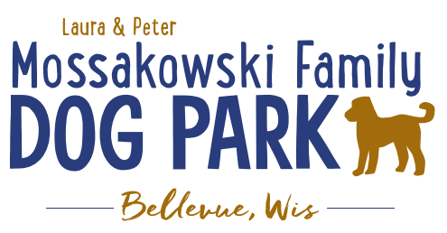
Laura and Peter Mossakowski Family Dog Park, LTD Committee Meeting

Date & Location: September 12th, 2018 @ 10:30am at Laura Mossakowski LLC (2555 Continental Dr.; Green Bay, 54311)

Meeting Began:

In attendance:

Secretary Report:
Approval of August minutes:

Treasurers Report:
Current Balance:
Outstanding Bills:
Incoming Donations

Community Fundraising:
Grant Writing – Updates
UWGB Student looking to intern (without credit) for Fall 2018 along with our current team
Samiirah has been put in contact with current team to help keep things rolling

Lincoln Fundraising Event – Dorsch Drive for Dogs

100 Women Who Care – Nov 7th; Presentation to be given – consider handouts and other items for promotion at event

Eagle Scout Project – (building permit needed through village – no charge), dimensions and plan made with Owen, initially build as a project that houses storage items and then will house pump for water until Trail Head building is built, then will be repurposed for another use later

Old Business:
Putting together a 3-5 year plan for the park to utilize for giving potential donors – differentiating grant items from donor items that will be needed for future phases
Ex. 2021 DNR Grant (50/50 match) for bridge but will need boardwalk before then, water items for this year, etc. to try to stay on the agendas for the municipalities to help with submissions

Construction & Maintenance Updates:
Phase II+ Planning (running topic) – need a closer idea / update estimates for items for future planning to help decide what will actually be in Phase II but initial thoughts include:
*Water Bubbler with human and dog faucet/washer – cost of running water needed
Est: $40-50,000 (based on where hook-up allows)
Proposed site and looking to get bids
Permits being sought
Pump housing also to include small amount of storage for items like waste bags
Water station looking to be set in a manner that will allow further parking expansion and be a “fun dog bone shape” to tie into the park – donations being sought for partnering with it or multiple donors being sought for it – bench to potentially have option for sponsorship recognition

Donation for the station for 2019 for the concrete and labor for installation of the water fountain – still need funding for the water/sewer coming to the area and the fountain itself (looking for about $25,000 in funding yet) – Would Bellevue potentially be an option to help with getting funds for getting the water in?
Impact fees from village not available for use until 2020

Trail-head Building and Area
Est: $300,000

Bridge cost
Est: $300,000

Entrance Structures and Picnic Shelter in Park
Est: $40,000

Kayak Launch
Est: $8,000 – may have some options for grants

Additional Parking & Lighting Option
Est: $25-30,000

Further Shade Structures – for further options in small dog area

Other – based on available funding, estimates, and available grants

Options for some shade structures for entrance areas to be built from Costco, etc. – continue to seek Eagle
Scout Projects

*Items to focus on for 2019

Next Meeting Dates: ________________________ at Laura Mossakowski LLC (2555 Continental Dr.; Green Bay, 54311)

New Business:
Continuing to build winter agenda topics – please pass thoughts along for 2019 discussion

Meeting Adjourned:

