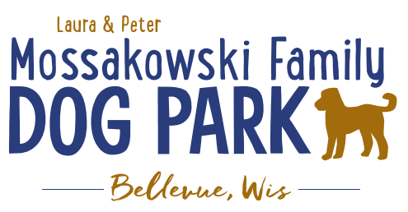
Laura and Peter Mossakowski Family Dog Park, LTD Committee Meeting

Date & Location: October 24th, 2018 @ 10:30am at Laura Mossakowski LLC (2555 Continental Dr.; Green Bay, 54311)

Meeting Began:

In attendance:

Secretary Report:
Approval of September minutes:

Treasurers Report:
Current Balance
Outstanding Bills:
Incoming Donations:

Community Fundraising:
Grant Writing – Updates

100 Women Who Care – Nov 7th; Presentation to be given – consider handouts and other items for promotion at event
Speaker ideas, need videos and pictures, etc.

Eagle Scout Project Update – (building permit needed through village – no charge), dimensions and plan made with Owen, initially build as a project that houses storage items and then will house pump for water until Trail Head building is built, then will be repurposed for another use later (waiting to hear back from Owen to see if interest is still there)

Old Business:

Construction & Maintenance Updates:
Start to look to get on the Village radar to look for planning for next year for approval so project can be started in spring

Phase II+ Planning (running topic) – need a closer idea / update estimates for items for future planning to help decide what will actually be in Phase II but initial thoughts include:
*Water Bubbler with human and dog faucet/washer – cost of running water needed
Est: $40-50,000 (based on where hook-up allows)
Proposed site and looking to get bids
Permits being sought
Pump housing also to include small amount of storage for items like waste bags
Water station looking to be set in a manner that will allow further parking expansion and be a “fun dog bone shape” to tie into the park – donations being sought for partnering with it or multiple donors being sought for it – bench to potentially have option for sponsorship recognition

Donation for the station for 2019 for the concrete and labor for installation of the water fountain – still need funding for the water/sewer coming to the area and the fountain itself (looking for about $25,000 in funding yet) – Would Bellevue potentially be an option to help with getting funds for getting the water in?
Impact fees from village not available for use until 2020 but need to be thought about for 2019

Close to having funding for the project to be started in 2019

Trail-head Building and Area
Est: $300,000

Bridge cost
Est: $300,000

Entrance Structures and Picnic Shelter in Park
Est: $40,000

Kayak Launch
Est: $8,000 – may have some options for grants

Additional Parking & Lighting Option
Est: $25-30,000

Further Shade Structures – for further options in small dog area

Other – based on available funding, estimates, and available grants

Options for some shade structures for entrance areas to be built from Costco, etc. – continue to seek Eagle
Scout Projects

*Items to focus on for 2019

Next Meeting Dates: ______________ @ _______ at Laura Mossakowski LLC (2555 Continental Dr.; Green Bay, 54311)

New Business:

Tentative date for K9 Karnival is May 11, 2019 – date was needed for Village to include in calendar

Dates for 2019 Events to be Planned – volunteer recruitment plan

Feces pick up for winter to prevent winter “pile-ups”

Meeting Adjourned:

