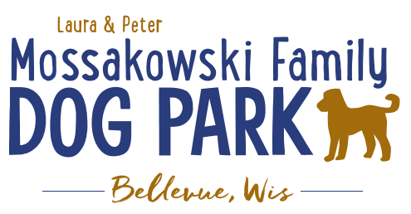
Laura and Peter Mossakowski Family Dog Park, LTD Committee Meeting

Date & Location: September 12th, 2018 @ 10:30am at Laura Mossakowski LLC (2555 Continental Dr.; Green Bay, 54311)

Meeting Began: 10:35a

In attendance: Laura Mossakowski, Paul Theys, Mark Schuster, Sandy Kemper, Jennie Wertel

Secretary Report:
Approval of August minutes: Paul, Laura

Treasurers Report:
Current Balance: $10,381 plus money at the village from passes
Outstanding Bills: Lizer
Incoming Donations: Drive for Dogs, donation, and CC points still coming in

Community Fundraising:
Grant Writing – Updates
UWGB Student looking to intern (without credit) for Fall 2018 along with our current team
Samiirah has been put in contact with current team to help keep things rolling
- Include general communication contacts for grant writing (funding@bellevuedogpark.com)
- Twitter and Facebook can also be helped
- Cliff Bar Grant projects – water and entrances
- Greater Green Bay Community Foundation

Lincoln Fundraising Event – Dorsch Drive for Dogs
Need more volunteers and more test drivers in future

100 Women Who Care – Nov 7th; Presentation to be given – consider handouts and other items for promotion at event
Speaker ideas, need videos and pictures, etc.

Eagle Scout Project – (building permit needed through village – no charge), dimensions and plan made with Owen, initially build as a project that houses storage items and then will house pump for water until Trail Head building is built, then will be repurposed for another use later (waiting to hear back from Owen to see if interest is still there)

Old Business:
Putting together a 3-5 year plan for the park to utilize for giving potential donors – differentiating grant items from donor items that will be needed for future phases
Ex. 2021 DNR Grant (50/50 match) for bridge but will need boardwalk before then, water items for this year, etc. to try to stay on the agendas for the municipalities to help with submissions
Charity to look to update a document that will help for getting info out

Construction & Maintenance Updates:
Start to look to get on the Village radar to look for planning for next year for approval so project can be started in spring

Phase II+ Planning (running topic) – need a closer idea / update estimates for items for future planning to help decide what will actually be in Phase II but initial thoughts include:
*Water Bubbler with human and dog faucet/washer – cost of running water needed
Est: $40-50,000 (based on where hook-up allows)
Proposed site and looking to get bids
Permits being sought
Pump housing also to include small amount of storage for items like waste bags
Water station looking to be set in a manner that will allow further parking expansion and be a “fun dog bone shape” to tie into the park – donations being sought for partnering with it or multiple donors being sought for it – bench to potentially have option for sponsorship recognition

Donation for the station for 2019 for the concrete and labor for installation of the water fountain – still need funding for the water/sewer coming to the area and the fountain itself (looking for about $25,000 in funding yet) – Would Bellevue potentially be an option to help with getting funds for getting the water in?
Impact fees from village not available for use until 2020 but need to be thought about for 2019

Close to having funding for the project to be started in 2019

Trail-head Building and Area
Est: $300,000

Bridge cost
Est: $300,000

Entrance Structures and Picnic Shelter in Park
Est: $40,000

Kayak Launch
Est: $8,000 – may have some options for grants

Additional Parking & Lighting Option
Est: $25-30,000

Further Shade Structures – for further options in small dog area

Other – based on available funding, estimates, and available grants

Options for some shade structures for entrance areas to be built from Costco, etc. – continue to seek Eagle
Scout Projects

*Items to focus on for 2019

Next Meeting Dates: October 24th, 2018 @ 10:30am at Laura Mossakowski LLC (2555 Continental Dr.; Green Bay, 54311)

New Business:
Continuing to build winter agenda topics – please pass thoughts along for 2019 discussion

Tentative date for K9 Karnival is May 11, 2019 – date was needed for Village to include in calendar

Meeting Adjourned: 11:30am

