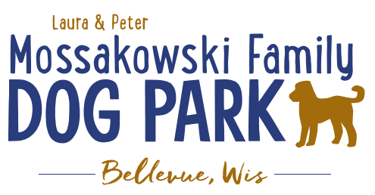
Board Meeting Agenda:

Meeting Began:

Attendance:

Officer Re-election
Laura Mossakowski – President
Sandy Kemper – Vice President
Paul Theys – Treasurer
Jennie Wertel – Secretary
Toni McBride – Director of Community Relations

Review of 2018 Meeting Minutes including prior Jan. 2, 2019 meeting

2019 Focus:
Phase II Planning – priority focus on water and sewer for the park as well as natural equipment/structures

K9 Karnival and Fundraising Planning
Consider asking Village for day pass for attendees of K9 Karnival again?

Added Events for the year:
Poochies and Pints Spring & Fall
Lincoln Drive for Dogs

Committee Building – continue to build on the size of the committee to be able to continue to offer more dog friendly events and opportunities such as Yoga in the Park, etc.
Social Media outreach to look for volunteers to help

Per the agreement with the Village the Committee is responsible for 50% of the maintenance where the Village is now responsible for 50% for the 2019 calendar year. The agreement will continue to mature to reach the 2021 goal where 100% of the cost of maintenance will be taken over by the Village.

Meeting Adjourned:

