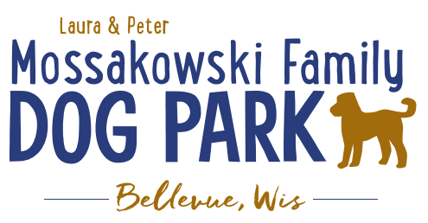
Laura and Peter Mossakowski Family Dog Park, LTD Committee Meeting

Date & Location: February 13, 2019 @ 9:15am at Laura Mossakowski LLC (2555 Continental Dr.; Green Bay, 54311)

Meeting Began:

In attendance:

Secretary Report:
Approval of January minutes:

Treasurers Report:
Current Balance: $___________ ($_____________ total with Village Account)
Village Account Update:
Village Known outstanding bills include:
Outstanding Bills:
Incoming Donations:

Community Fundraising:
Grant Writing – Updates
Intern (Ketti) UWGB Student Started, getting started with Grant Research and picking up where others left off
Jennie to do Packers Grant – available to start in 2019

2019 Fundraising Events (Running Topic):
Date for K9 Karnival is May 11, 2019 – Jennie helping as Coordinator
Discuss 2019 Plan and begin solidifying roles for 2019 K9 Karnival

Spring Poochies and Pints June 13th, 2019 – Allouez has January meeting set for planning further

Fall Poochies and Pints – date TBD in September

Lincoln Drive for Dogs Event in fall?? – Ken Miller Bellevue Resident that is on the planning committee for the Prince of Peace Car Show
Event would need to be planned out with more details secured before approval

Old Business:
Construction & Maintenance Updates:
Looking to get bids prepared and accepted for getting out in February

Permits needed for running water/sewer under road

Coordinating with Owen for building dog house structure for pump housing

Phase II+ Planning (running topic) – need a closer idea / update estimates for items for future planning to help decide what will actually be in Phase II but initial thoughts include:
*Water Bubbler with human and dog faucet/washer – cost of running water needed
Est: $40-50,000 (based on where hook-up allows)
Proposed site and looking to get bids
Permits being sought
Pump housing also to include small amount of storage for items like waste bags
Water station looking to be set in a manner that will allow further parking expansion and be a “fun dog bone shape” to tie into the park – donations being sought for partnering with it or multiple donors being sought for it – bench to potentially have option for sponsorship recognition

Donation for the station for 2019 for the concrete and labor for installation of the water fountain – currently have the funds in place to start but still looking for possible naming rights and final donations

Funds secured for project to be started in 2019 but additional donations still being looked for

Restrooms will ultimately have two stalls in women’s with 2 sinks and one stall and one urinal in men’s with 2 sinks and there will need to be a utility sink

Trail-head Building and Area
Est: $300,000

Bridge cost
Est: $300,000

Entrance Structures and Picnic Shelter in Park
Est: $40,000

Kayak Launch
Est: $8,000 – may have some options for grants
2021 DNR Grants may have options here

Additional Parking & Lighting Option
Est: $25-30,000

Further Shade Structures – for further options in small dog area

Multi-use Trails to get to particular areas (kayak launch, bridge, etc.)

Other – based on available funding, estimates, and available grants

Options for some shade structures for entrance areas to be built from Costco, etc. – continue to seek Eagle
Scout Projects

*Items to focus on for 2019

Next Meeting Dates: ________________ @ 9:15am at Laura Mossakowski LLC (2555 Continental Dr.; Green Bay, 54311)

New Business:
Look to set up a discussion with the Village of Allouez to discuss making sure we understand their long range plan for being able to connect the Dog Park with their parks system

Meeting Adjourned:

