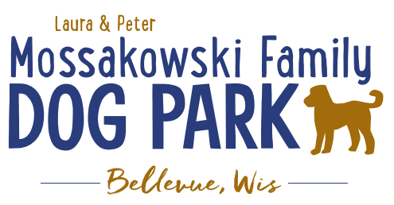
Laura and Peter Mossakowski Family Dog Park, LTD Committee Meeting

Date & Location: March 13, 2019 @ 9:15am at Laura Mossakowski LLC (2555 Continental Dr.; Green Bay, 54311)

Meeting Began:

In attendance:

Secretary Report:
Approval of February minutes:

Treasurers Report:
Current Balance: $ ($ total with Village Account)
Village Account Update:
Village Known outstanding bills include:
Outstanding Bills:
Incoming Donations:

Community Fundraising:
Grant Writing – Updates
Intern (Ketti) UWGB Student started on new grants and building previous list
Jennie to do Packers Grant – Opens March 2019
Second intern potentially interested for Summer

2019 Fundraising Events (Running Topic):
Date for K9 Karnival is May 11, 2019 – Jennie working as Coordinator
Discuss 2019 Plan and begin solidifying roles for 2019 K9 Karnival

Rain date:

May 1st 100 Women Who Care Event – Dog Park chosen to be eligible for selection again – presentation needed (needs to be updated and fresh – IDEAS NEEDED!) Location – GB Country Club

Spring Poochies and Pints June 13th, 2019 – volunteers needed

Fall Poochies and Pints – tentative date Oct 5th noon-4pm, looking to lock in date by end of April

Lincoln Drive for Dogs Event moved to 2020

Old Business:
Construction & Maintenance Updates:
Looking to get bids prepared and accepted for getting out in February

Permits needed for running water/sewer under road

Coordinating with Owen for building dog house structure for pump housing

Looking to solidify plans for water fountain(s)

Looking for options for drainage based on needs from DNR

Phase II+ Planning (running topic) – need a closer idea / update estimates for items for future planning to help decide what will actually be in Phase II but initial thoughts include:
*Water Bubbler with human and dog faucet/washer
Est: $40-50,000 (based on where hook-up allows)

Trail-head Building and Area
Est: $300,000

Bridge cost
Est: $300,000

Entrance Structures and Picnic Shelter in Park
Est: $40,000

Kayak Launch
Est: $8,000 – may have some options for grants
2021 DNR Grants may have options here

Additional Parking & Lighting Option
Est: $25-30,000

Further Shade Structures – for further options in small dog area

Multi-use Trails to get to particular areas (kayak launch, bridge, etc.)

Other – based on available funding, estimates, and available grants

Options for some shade structures for entrance areas to be built from Costco, etc. – continue to seek Eagle
Scout Projects

*Items to focus on for 2019

Next Meeting Dates: ____________ @ 9:15am at Laura Mossakowski LLC (2555 Continental Dr.; Green Bay, 54311)

New Business:
Bellevue Dog Days of Summer photo contest

Meeting Adjourned:

