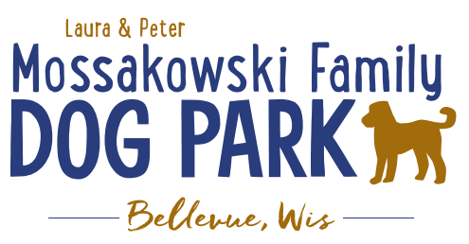
Laura and Peter Mossakowski Family Dog Park, LTD Committee Meeting

Date & Location: March 13, 2019 @ 9:15am at Laura Mossakowski LLC (2555 Continental Dr.; Green Bay, 54311)

Meeting Began: 9:20am

In attendance: Toni McBride, Adam Waszak, Laura Mossakowski, Jennie Wertel

Secretary Report:
Approval of February minutes: Laura, Toni

Treasurers Report:
Current Balance: $18,663.49 ($43,240.37 total with Village Account)
Village Account Update:
Village Known outstanding bills include: none
Outstanding Bills:
Incoming Donations: LPL matching donation

Community Fundraising:
Grant Writing – Updates
Intern (Ketti) UWGB Student started on new grants and building previous list
Ketti working with Ashley Bethke to look for other grants and donation options
Jennie to do Packers Grant – Opens March 2019
Second intern potentially interested for Summer

2019 Fundraising Events (Running Topic):
Date for K9 Karnival is May 11, 2019 – Jennie working as Coordinator
Discuss 2019 Plan and begin solidifying roles for 2019 K9 Karnival

Rain date: Saturday, May 18th

Laura Mossakowski LLC Title Sponsor; Gentle Vet Partner Sponsor

May 1st 100 Women Who Care Event – Dog Park chosen to be eligible for selection again – presentation needed (needs to be updated and fresh – IDEAS NEEDED!) Location – GB Country Club
Presenter to be looked for
Ideas for presentation

Spring Poochies and Pints June 13th, 2019 – volunteers needed

Fall Poochies and Pints – tentative date Oct 5th noon-4pm, looking to lock in date by end of April

Lincoln Drive for Dogs Event moved to 2020

Old Business:
Construction & Maintenance Updates:
Looking to get bids prepared and accepted for getting out in Spring 2019
Permits needed for running water/sewer under road
Coordinating with Owen for building dog house structure for pump housing
Looking to solidify plans for water fountain(s)
Looking for options for drainage based on needs from DNR

Phase II+ Planning (running topic) – need a closer idea / update estimates for items for future planning to help decide what will actually be in Phase II but initial thoughts include:
*Water Bubbler with human and dog faucet
Est: $40-50,000 (based on where hook-up allows)

Trail-head Building and Area
Est: $300,000

Bridge cost
Est: $300,000

Entrance Structures and Picnic Shelter in Park
Est: $40,000

Kayak Launch
Est: $8,000 – may have some options for grants
2021 DNR Grants may have options here

Additional Parking & Lighting Option
Est: $25-30,000

Further Shade Structures – for further options in small dog area
Entrance structures – 100 Women Who Care
Multi-use Trails to get to particular areas (kayak launch, bridge, etc.)
Other – based on available funding, estimates, and available grants
Options for some shade structures for entrance areas to be built from Costco, etc. – continue to seek Eagle
Scout Projects

*Items to focus on for 2019

Next Meeting Dates: April 10th, 2019 @ 9:15am at Laura Mossakowski LLC (2555 Continental Dr.; Green Bay, 54311)
April 24th, 2019 @ 10am at Laura Mossakowski LLC (2555 Continental Dr.; Green Bay, 54311) *Focus K9 Karnival and 100 Women Who Care
May 8th, 2019 @ 9:15am at Laura Mossakowski LLC (2555 Continental Dr.; Green Bay, 54311) *Focus K9 Karnival and Poochies and Pints
June 5th, 2019 @ 9:15am at Laura Mossakowski LLC (2555 Contintental Dr.; Green Bay, 54311) *Focus Poochies and Pints

New Business:
Bellevue Dog Days of Summer photo contest – Ambrosious studios looking to help sponsor it and the park committee will help to pick winner. Pics taken out of the park and contest to pick best pics. Featured in program guide and Labor Day Weekend Deadline (all dog park pass holders eligible).

Meeting Adjourned: 10:30am

