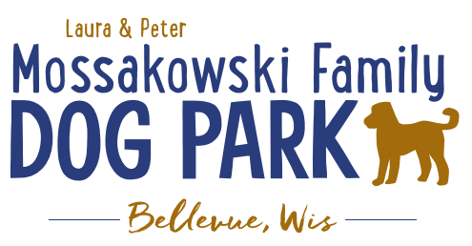
Laura and Peter Mossakowski Family Dog Park, LTD Committee Meeting

Date & Location: June 5, 2019 @ 9:15am at Laura Mossakowski LLC (2555 Continental Dr.; Green Bay, 54311)

Meeting Began: 9:20a

In attendance: Paul Theys, Laura Mossakowski, Toni McBride, Charity Schneider, Jennie Wertel

Secretary Report:
Approval of May minutes: Paul, Laura

Treasurer Report:
Current Balance: $23,393 ($47,970 total with Village Account)
Village Account Update:
Village Known outstanding bills include: Public Works for Snow Removal, WPS, and Port-a-John, Envelopes
Outstanding Bills: Mr. Doody Pet Waste Service, CPA
Incoming Donations: Poochies and Pints events coming up

Community Fundraising:
Grant Writing – Updates
Jennie to do Packers Grant – Opens May 2019
Social Media Team – reach out to find other places to search for grants
Potential Interns from UWGB looking to explore options for upcoming semesters

2019 Fundraising Events (Running Topic):
K9 Karnival Wrap-up and Final Thoughts to Remember for Next Year
Hit marketing a little sooner to allow fliers and other promo to be available at other businesses
Press Release from group highlighting event details to get media there the day of
Consider moving it to the weekend before Memorial Day Weekend
Revamp Flyers to new format
Look at other ways to revamp the event – fenced area for play off leash, change time of day and have other beverage/food options, change location, more family friendly events, etc.
Look at goal/primary focus? Family, funds, community focus, etc.
Location, Time, Date
(ball park in Allouez?, etc.)

Spring Poochies and Pints June 13th, 2019 from 4-8pm @ Green Isle Park, Allouez
Update and planning

5 breweries
Signage done
No Rain Date
Volunteers needed
Food Trucks
Ice cream Truck
Working on Vendors
Setting up layout
2 Raffle items/baskets (big items)
Soda/water available
Allouez/Green Bay AH to do educational talks

Fall Poochies and Pints - Oct 12th noon-4pm

Old Business:
Feces Clean Up at Park – Sandy Kemper doing it per contract – going well

Construction & Maintenance Updates:
Looking to get bids prepared and accepted for getting out in Spring 2019
Permits needed for running water/sewer under road
Coordinating with Owen for building dog house structure for pump housing
Looking to solidify plans for water fountain(s)
Looking for options for drainage based on needs from DNR

Phase II+ Planning (running topic) – need a closer idea / update estimates for items for future planning to help decide what will actually be in Phase II but initial thoughts include:

*Water Bubbler with human and dog faucet (no sanitary sewer at this time)
Est: $20-30,000 (based on where hook-up allows)
Water meter location TBD based on ongoing planning

Trail-head Open Air Shelter (w/o bathrooms)
Est: $____________

Bridge cost
Est: $300,000

Entrance Structures and Picnic Shelter in Park
Est: $40,000

Kayak Launch
Est: $8,000 – may have some options for grants
2021 DNR Grants may have options here

Additional Parking & Lighting Option
Est: $25-30,000

Park Drainage
Est: $_____________

Further Shade Structures – for further options in small dog area
Entrance & Shade Structures –
Multi-use Trails to get to particular areas (kayak launch, bridge, etc.)
Other – based on available funding, estimates, and available grants
Options for some shade structures for entrance areas – continue to seek Eagle Scout Projects

*Items to focus on for 2019

Next Meeting Dates: TBD

New Business:

Meeting Adjourned: 10:30am

For next meeting:
Bricks/stones – memorial options (sizes, etc.)
Doc Dogs – options similar to lure course
Free Veterinary Checkups
NT’s, baths, etc.

