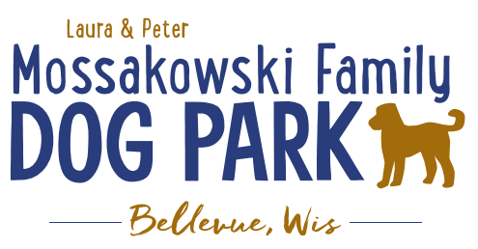
Laura and Peter Mossakowski Family Dog Park, LTD Committee Meeting

Date & Location: October 23rd, 2019 @ 9:15am at Laura Mossakowski LLC (2555 Continental Dr.; Green Bay, 54311)

Meeting Began:

In attendance:

Secretary Report:
Approval of September minutes:

Treasurer Report:
Current Balance: $______________ ($_______________ total with Village Account)
Village Account Update:
Village Known outstanding bills include:
Outstanding Bills: Mr. Doody Pet Waste Service, Robert E Lee
Incoming Donations: Poochies and Pints event

Community Fundraising:
Grant Writing – Updates
Packers Grant Submitted and has been assigned to a committee member for processing and follow up

2020 Summer Pup Olympics (Running Topic) – Look at Josten Park due to construction at the Dog Park
Food trucks, vendors, and beverages in addition to the return of the bounce house and other family activities
Tentative Date: June 27th, 2020

Memorial fundraisers – small gardens, rocks and other structures, plaques, benches, etc.
A few hydrants to be installed and plaques made
Looking to price memorial stones to use either on the ground or on a structure

Old Business:
Construction & Maintenance Updates:
Permits needed for running water/sewer under road - obtained
Coordinating with Owen for Eagle Scout Project- completed
Looking to solidify plans for water fountain(s)

Phase II+ Planning (running topic):

*Water Bubbler with human and dog faucet (no sanitary sewer at this time)
Est: $20-30,000 (based on where hook-up allows)
Water meter location TBD based on ongoing planning

Trail-head Open Air Shelter (w/o bathrooms)
Est: $____________

Bridge cost
Est: $300,000

Entrance Structures and Picnic Shelter in Park
Est: $40,000

Kayak Launch
Est: $8,000 – may have some options for grants
2021 DNR Grants may have options here

Additional Parking & Lighting Option
Est: $25-30,000

Park Drainage
Est: $_____________

Further Shade Structures – for further options in small dog area
Entrance & Shade Structures –
Multi-use Trails to get to particular areas (kayak launch, bridge, etc.)
Other – based on available funding, estimates, and available grants
Options for some shade structures for entrance areas – continue to seek Eagle Scout Projects

*Items to focus on for 2020

Next Meeting Dates: __________________ (9:15am at Laura Mossakowski LLC; 2555 Continental Dr., Green Bay)

New Business:
Mark introduced new DNR grant that must be applied for by Bellevue/Allouez by December 2019 – consider for bridge, boardwalk, etc – 90% co-pay award

Website help has decided to step away

Meeting Adjourned:

