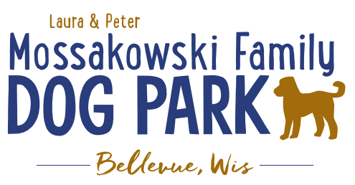
Board Meeting Minutes
Meeting Began:
Attendance:

Officer Election/Re-election – Motion to re-elect the following positions President, Treasurer, Secretary
All in favor:
Opposed:

Current Board Members:
Laura Mossakowski – President
Paul Theys – Treasurer
Jennie Wertel – Secretary

Review of 2019 Meeting Minutes including prior Jan. 15, 2020 meeting –

2020 Focus:
Phase II Planning – priority focus on water and sewer for the park including the water structure for 2020

K9 Karnival Event to be updated and revamped and moved to June

Other Events for the year:
Poochies and Pints Spring & Fall

Committee Building – continue to build on the size of the committee to be able to continue to offer more dog friendly events and opportunities such as Yoga in the Park, etc.

Increase Social Media push for events and volunteers – goal is to increase people to come to events and awareness of park and increase the number of volunteers helping at events

Per the agreement with the Village the Committee is responsible for 25% of the maintenance where the Village is now responsible for 75% for the 2020 calendar year. The agreement will continue to mature to reach the 2021 goal where 100% of the cost of maintenance will be taken over by the Village.

Meeting Adjourned:

