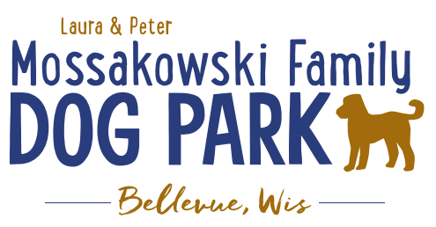
Laura and Peter Mossakowski Family Dog Park, LTD Committee Meeting

Date & Location: February 26th, 2020 @ 9:15amat Laura Mossakowski LLC (2555 Continental Dr.; Green Bay, 54311)

Meeting Began:

In attendance:

Secretary Report:
Approval of Januaryminutes:

Treasurer Report:
Current Balance: $ __________ ($_______ est. total with Village Account)
Village Account Update:End of year update $34,306.99
Village Known outstanding bills include:normal winter maintenance upcoming
Outstanding Bills: Mr. Doody Pet Waste Service, Stickers
Incoming Donations:

Community Fundraising:
Grant Writing – new volunteers helping to get Grants rolling again

2020 Dog Park Birthday Celebration (Running Topic) – Look at Josten Park due to construction at the Dog Park
Vendors, and beverages in addition to the return of the bounce house and other family activities
Tentative Date: June 27th, 2020
Revise layout to watch flow and keep vendors up front?
Jump Around Bounce Houses – out of Appleton (just would need someone to staff it) – bounce house, bounce house/slide combo, obstacle course options
Booth vendors – with activity can have reduced fee?? – still have a hold fee, offer electronic funds transfer, etc.
Beer Truck Vendor?
Consider moving the event to a different area of the park
Off leash area in tree area or back field area – volunteers to help watch but owners also needed to stay in area with them
Dock Dogs?, Agility, K9 Demos, Scent Dog Demos, etc.
Social Media Seeking for Coordinator/possible event help
3rd Anniversary of Dog Park Celebration/Acknowledgement – cake for people/dogs
Doggie Beer

Memorial fundraisers – small gardens, rocks and other structures, plaques, benches, etc.
A few hydrants to be installed and plaques made
Looking to price memorial stones to use either on the ground or on a structure
$2500+ Fire hydrants or memorial boulders
Need hydrant for Broadway

Old Business:
Mark introduced new DOT grant that must be applied for by Bellevue/Allouez by December 2019 – consider for bridge, boardwalk, etc – 90% co-pay award

Social Media Outreach – Begin to look at getting posts going to encourage annual passes as weather warms

Construction & Maintenance Updates:
Permits needed for running water/sewer under road– obtained
Approval for Bid:

Phase II+ Planning (running topic):

*Water Bubbler with human and dog faucet (no sanitary sewer at this time)
Est: $50-60,000 (based on where hook-up allows)

Shade Structure in Small Dog Area
Consider options for structure – same vs different than in large dog area, location, etc., Packers Grant to help cover some of structure

When pouring concrete next consider adding a few slabs for future hydrant installation
Extra in small dog area and large dog area

Next Meeting Dates:_________________, 2020 (9:15am at Laura Mossakowski LLC; 2555 Continental Dr., Green Bay)

New Business:
Interest in being a vendor at the Pet Walk Sunday, June 7?

Meeting Adjourned:

