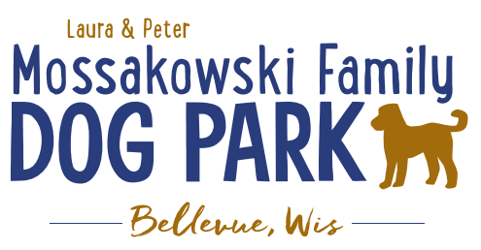
Laura and Peter Mossakowski Family Dog Park, LTD Committee Meeting

Date & Location: January 15th, 2020 @ 9:15amat Laura Mossakowski LLC (2555 Continental Dr.; Green Bay, 54311)

Meeting Began:

In attendance:

Secretary Report:
Approval of Novemberminutes:

Treasurer Report:
Current Balance: $_______________ ($_________________total with Village Account)
Village Account Update:
Village Known outstanding bills include:normal winter maintenance upcoming
Outstanding Bills: Mr. Doody Pet Waste Service
Incoming Donations:

Community Fundraising:
Grant Writing –

2020 Summer Pup Olympics (Running Topic) – Look at Josten Park due to construction at the Dog Park
Vendors, and beverages in addition to the return of the bounce house and other family activities
Tentative Date: June 27th, 2020
Revise layout to watch flow and keep vendors up front?
Jump Around Bounce Houses – out of Appleton (just would need someone to staff it)
Booth vendors – with activity can have reduced fee?? – still have a hold fee, offer electronic funds transfer, etc.
Beer Truck?
Consider moving the event to a different area of the park
Off leash area in tree area or back field area – volunteers to help watch but owners also needed to stay in area with them
Dock Dogs?, Agility, K9 Demos, Scent Dog Demos, etc.
Social Media Seeking for Coordinator??

Possible interested event help?

Memorial fundraisers – small gardens, rocks and other structures, plaques, benches, etc.
A few hydrants to be installed and plaques made
Looking to price memorial stones to use either on the ground or on a structure
$2500+ Fire hydrants or memorial boulders

Old Business:
Mark introduced new DOT grant that must be applied for by Bellevue/Allouez by December 2019 – consider for bridge, boardwalk, etc – 90% co-pay award
Mark can help provide some info but the village needs to submit the info – working with Adam and possibly Allouez
Due Dec. 6th

Social Media Outreach – seek help for website? Seek event coordinator?

Amazon Charity List – can list items such as poop bags, trees, agility equipment, shade tents, event items, shade/entrance structures, etc.

Construction & Maintenance Updates:
Permits needed for running water/sewer under road– obtained
Looking to rebid project soon
Coordinating with Owen for Eagle Scout Project- completed
Looking to solidify plans for water fountain(s)

Phase II+ Planning (running topic):

*Water Bubbler with human and dog faucet (no sanitary sewer at this time)
Est: $20-30,000 (based on where hook-up allows)
Looking to rebid in 2020 (early)

Shade Structure in Small Dog Area
Consider options for structure – same vs different than in large dog area, location, etc., Packers Grant to help cover some of structure

When pouring concrete next consider adding a few slabs for future hydrant installation

Next Meeting Dates:January 15th, 2020 (9:15am at Laura Mossakowski LLC; 2555 Continental Dr., Green Bay)
*December date only planned if needed, meetings will resume in January 2020

New Business:

Meeting Adjourned:

