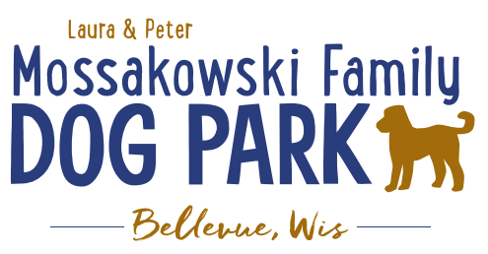
Laura and Peter Mossakowski Family Dog Park, LTD Committee Meeting

Date & Location: August 12, 2020 9:15a @ Laura Mossakowski LLC (2555 Continental Dr.; Green Bay, WI 54311)

Meeting Began:

In attendance:

Secretary Report:
Approval of July minutes:

Treasurer Report:
Current Balance: $______________ ($_____________ est. total with Village Account)
Village Account Update:
Village Known outstanding bills include:
Outstanding Bills: Mr. Doody Pet Waste Service, Water Installation/Construction (~$53,000)
Incoming Donations:

Community Fundraising:
Grant Writing
Adam and Erin –
- American Academy of Dermatology – shade structure grant option, they choose the structure, letter needs to come from an academy member dermatologist, typically due in December, more details being looked into, max $8,000 to go towards shade structure and installation along with sign with sun safety tips (Need letter from AAD member, ideally from GB, and guideline book to pick from for structure, but will need to demonstrate ongoing commitment to sun safety with materials they provide)
- Harley Davidson Foundation Grant – details being looked into, reviewed quarterly (June, September, etc.), need to start application before seeing all of the details

Looking to start to canvas park goers to see where guests feel other fundraising efforts should be going

Memorial fundraisers – small gardens, rocks and other structures, plaques, benches, etc.
Donn @ Forever Friends has rock options that can be looked into (examples available for next in person meeting) – stones not meant to be walked on but meant for outdoor display
Fine tune details and pricing for future meeting
Bricks starting at $200, incorporated into the shade structure
Memorial benches also – Starting at $2500; hydrant starting at $5,000
Memorial options on other benches and small plaques on the shade structure
Memorial/sponsorship on roof of pavilion
Sample brick gotten, laser printed, may be allow a lower cost option but want to be sure it is sturdy – min $100 to purchase

A few hydrants to be installed and plaques made; $2500+ Fire hydrants or memorial boulders
Need hydrant for Malley
Second slab poured for future hydrant

Memorial bricks roll out soon – difficulty finding some of lower cost that are meant to hold up

Consider virtual fundraiser
Log time and enter a raffle – check ins get entry, enter a raffle for every check in,

Facebook Live event for opening of the water fountain

Scavenger hunt with QR scans to answer a phrase
Questions to include history of park, etc. – all answers able to be found on website
At least one question to include an option for providing feedback on what the park go-ers feel should be an ongoing goal for the park

Old Business:
Construction & Maintenance Updates:
Shade Structure in Small Dog Area
Consider options for structure – same vs different than in large dog area, location, etc., Packers Grant to help cover some of structure
Looking at location of being in the corner to the left when you enter the small dog area and consider close to the fence to allow possible shade to spread into large dog area

Can impact fees go towards difference from Packers Grant – Parks Commission awarded park funds to help with this July 2020 –Park Commission gave recommendation for $17,000 for the help with the structure, Village Board needs to give approval (July 22 @ 6:30p) to go on for bidding process, then look for end of August to move forward with a builder

Village of Bellevue denied funding – no real reason given or no options for how approval would be granted

Little Free Library Addition at entrance? – allow for sponsorship of it, would need ongoing monitoring to ensure appropriate material is in there, should be OK (Consider FB push for sponsorship) – When a Little Free Library is obtained, then seek sponsor, seek request with Brown Co Library to see if they have options for putting it up and watching them

Looking to planning for the future for the next round of DNR grants for the bridge in the future, next round due May 1, 2021 (50:50 match)
Pair with Allouez on collaborative plan for boardwalk and bridge

Next Meeting Dates:______________ (9:15am at Laura Mossakowski LLC; 2555 Continental Dr., Green Bay OR Zoom teleconference meeting)

New Business:
Maintenance needs: ramps for the agility equipment, puddle when you enter the large dog area, area near gate seems to be getting high again – need adjustment, gravel addition? - consider leash hook up near the water station? (attached to the fountain??)

Meeting Adjourned:

