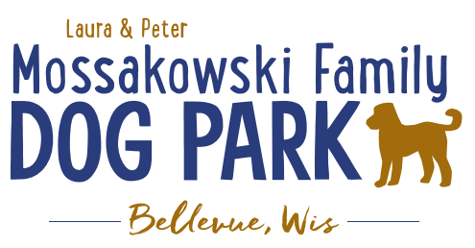
Laura and Peter Mossakowski Family Dog Park, LTD Committee Meeting

Date & Location: September 23, 2020 9:15a @ Laura Mossakowski LLC (2555 Continental Dr.; Green Bay, WI 54311)

Meeting Began:

In attendance:

Brief Committee Board Discussion: Nominate Erin Mader to Board Secretary position
Accept:
In favor:
Opposed:
Approval/Denial

VP Report:
Approval of August minutes:

Treasurer Report:
Current Balance: $___________ ($___________est. total with Village Account)
Village Account Update:
Village Known outstanding bills include:
Outstanding Bills: Mr. Doody Pet Waste Service
Incoming Donations:

Secretary Report:

Community Fundraising:
Grant Writing
Adam and Erin –
- American Academy of Dermatology – shade structure grant option, they choose the structure, letter needs to come from an academy member dermatologist, typically due in December, more details being looked into, max $8,000 to go towards shade structure and installation along with sign with sun safety tips (Need letter from AAD member, ideally from GB, and guideline book to pick from for structure, but will need to demonstrate ongoing commitment to sun safety with materials they provide)
- Harley Davidson Foundation Grant – details being looked into, reviewed quarterly (June, September, etc.), need to start application before seeing all of the details

Applied for $5,000 grant through LPL

MDRT possible grant application to be completed

Can Village or Parks Commission put some more emphasis on DNR and other grants for the park since the park is the most popular & profitable park in the village?

Memorial fundraisers – small gardens, rocks and other structures, plaques, benches, etc.
Donn @ Forever Friends has rock options that can be looked into (examples available for next in person meeting) – stones not meant to be walked on but meant for outdoor display
Fine tune details, location, and pricing for future meeting
Bricks starting at $200 unless lower cost option found
Memorial benches also – Starting at $2500; hydrant starting at $5,000
Memorial options on other benches and small plaques on the shade structure

Sample brick gotten, laser printed, may be allow a lower cost option but want to be sure it is sturdy – min $100 to purchase – consider testing for durability

A few hydrants to be installed and plaques made; $2500+ Fire hydrants or memorial boulders
Need hydrant for Malley
Second slab poured for future hydrant

Local dog park user has offered to discuss options for making shirts/can coolers – Mostly an order as needed or keep a stock. Cost will depend on order size.

Consider virtual fundraiser
Facebook Live event for opening of the water fountain – Sept 26th? – mini work day time?
Scavenger hunt with QR scans to answer a phrase – roll out Sept 26th?
Questions to include history of park, etc. – all answers able to be found on website
At least one question to include an option for providing feedback on what the park go-ers feel should be an ongoing goal for the park

Old Business:
Construction & Maintenance Updates:
Shade Structure in Small Dog Area
Consider options for structure – consider adding a similar structure to other areas of the park due to lack of Village support?

Looking to planning for the future for the next round of DNR grants for the bridge in the future, next round due May 1, 2021 (50:50 match)
Pair with Allouez on collaborative plan for boardwalk and bridge?

Next Meeting Dates: ______________, 2020 (9:15am at Laura Mossakowski LLC; 2555 Continental Dr., Green Bay OR Zoom teleconference meeting)

New Business:
Maintenance needs: puddle when you enter the large dog area, area near gate seems to be getting high again – need adjustment, gravel addition

Dog Park Work Time September, 26th 11a – 1p - pour concrete for hydrants, post for little free library, plan memorial stone area location, FB live opening of the water bubbler area, QR scavenger hunt intro

Look to get village to take over dog waste and all maintenance per the contract – as of 2021 the Village is responsible for 100% maintenance costs

Meeting Adjourned:

