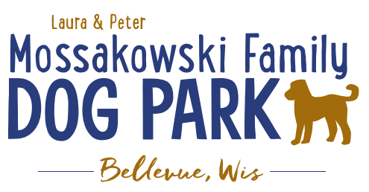
Laura and Peter Mossakowski Family Dog Park, LTD Committee Meeting

Date & Location: November 4, 2020 9:15a @ Laura Mossakowski LLC (2555 Continental Dr.; Green Bay, WI 54311)

Meeting Began:

In attendance:

VP Report:
Approval of August minutes:

Treasurer Report:
Current Balance: $_____________ ($_____________est. total with Village Account)
Village Account Update: $12,594 from Fall 2020 update
Village Known outstanding bills include:
Outstanding Bills: Mr. Doody Pet Waste Service, Tax return
Incoming Donations:

Secretary Report:

Community Fundraising:
Grant Writing
Adam and Erin –
- American Academy of Dermatology – shade structure grant option, they choose the structure, letter needs to come from an academy member dermatologist, typically due in December, more details being looked into, max $8,000 to go towards shade structure and installation along with sign with sun safety tips (Need letter from AAD member, ideally from GB, and guideline book to pick from for structure, but will need to demonstrate ongoing commitment to sun safety with materials they provide)
- Harley Davidson Foundation Grant – details being looked into, reviewed quarterly (June, September, etc.), need to start application before seeing all of the details

Applied for $5,000 grant through LPL

MDRT possible grant application to be completed

Memorial fundraisers – small gardens, rocks and other structures, plaques, benches, etc.
Donn @ Forever Friends has rock options that can be looked into (examples available for next in person meeting) – stones not meant to be walked on but meant for outdoor display
Fine tune details, location, and pricing for future meeting
Bricks starting at $200 unless lower cost option found
Memorial benches also – Starting at $2500; hydrant starting at $5,000
Memorial options on other benches and small plaques on the shade structure

Sample brick gotten, laser printed, may be allow a lower cost option but want to be sure it is sturdy – min $100 to purchase– Test brick at the park

A few hydrants to be installed and plaques made; $2500+ Fire hydrants or memorial boulders
Slabs poured, ready for hydrants

Old Business:
Construction & Maintenance Updates:
Shade Structure in Small Dog Area
Still an option for 2020?

Winterizing to be done Mid/late October, will open up in spring ASAP

Next Meeting Dates:______________ (9:15am at Laura Mossakowski LLC; 2555 Continental Dr., Green Bay OR Zoom teleconference meeting)

New Business:
Scavenger hunt updated with QR options to build a phrase – multiple choice (put it up and intro on Saturday at the work day) – 10 questions to create a phrase, instructions to be hung at each gate and posted on FB, completion gets entry into drawing for prize

As of 2021 the Village is responsible for 100% maintenance costs – will likely price it out waste pick up and then look over the agreement as a team in the coming months to ensure everyone is all in the same understanding

Meeting Adjourned:

