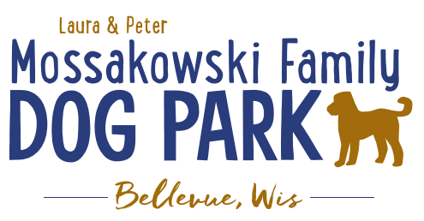
Board Meeting Minutes
January 20, 2021
Meeting Began:
Attendance:

Officer Election/Re-election – Motion to re-elect the following positions President, Vice President, Treasurer, & Secretary
All in favor:
Opposed:

Current Board Members:
Laura Mossakowski – President
Paul Theys – Treasurer
Jennie Wertel – Vice President
Erin Mader – Secretary

Review of 2019 Meeting Minutes including prior January 21, 2021 meeting –
Approved:
Opposed:

2020 Focus:
Phase II Planning – priority focus on shade structure in small dog area

K9 Karnival Event to be updated and revamped and moved to June Birthday Party Celebration–based on COVID restrictions

Committee Building – continue to build on the size of the committee to be able to continue to offer more dog friendly events and opportunities such as Yoga in the Park, etc.

Increase Social Media push for events and volunteers – goal is to increase people to come to events and awareness of park and increase the number of volunteers helping at events

Per the agreement with the Village the Committee is responsible for 0% of the maintenance where the Village is now responsible for 100% for the 2021 calendar year.

Meeting Adjourned:

