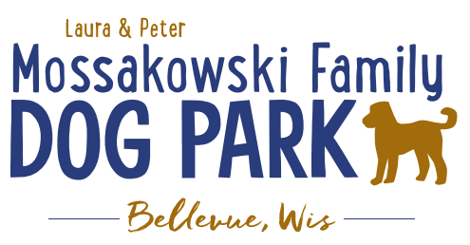
Laura and Peter Mossakowski Family Dog Park, LTD Committee Meeting

Date & Location: January 20, 2021 @ 9:15a @ Laura Mossakowski LLC (2555 Continental Dr.; Green Bay, WI 54311)

Meeting Began: 9:15am

In attendance: Erin Mader, Paul Theys, Laura Mossakowski, Mark Schuster, Jennie Wertel, Adam Waszak

VP Report:
Approval of November minutes: Laura, Paul

Treasurer Report:
Current Balance: $28,760 ($41,350 est. total with Village Account)
Village Account Update: $13,593 from December 2020 update
Village Known outstanding bills include: portapotty rental for last few months
Outstanding Bills:
Incoming Donations:

Secretary Report:
No updates

Community Fundraising:
Grant Writing
Adam and Erin

Memorial fundraisers – small gardens, rocks and other structures, plaques, benches, etc.
Donn @ Forever Friends has rock options that can be looked into (examples available for next in person meeting) – stones not meant to be walked on but meant for outdoor display
Fine tune details, location, and pricing for future meeting
Bricks starting at $200 unless lower cost option found
Memorial benches also – Starting at $2500; hydrant starting at $5,000
Memorial options on other benches and small plaques on the shade structure

Sample brick gotten, laser printed, may be allow a lower cost option but want to be sure it is sturdy – min $100 to purchase – Test brick at the park

An additional brick company was found by way of another area fundraiser, looking into

A few hydrants to be installed and plaques made; $2500+ Fire hydrants or memorial boulders
Slabs poured, ready for hydrants – Parks to install
Memorial plaque needed for Malley’s hydrant (Office Sign Company can be looked into – outdoor safe?)

DNR funding / grants: Adam to help work on planning for upcoming grants and funds that can be used for ongoing projects 2021 grant application for 2022 projects (board walk and bridge as goals) – also looking to get Allouez involved to get the application going
Condos want to expand and get connected to East River trail as well
Adam started applications last week, letter of support and help from Allouez being sought

Old Business:
Construction & Maintenance Updates:
Shade Structure in Small Dog Area
Co-Op quote: shelter material is $9,300 + $15,412 for install from this vendor = ~$25K + the cost of a concrete pad = total cost of the project (without getting other quotes)
Consider getting local quotes for portions of project – Any suggestions for other contractors? Discussion with original quote provider to see why so high? Can consider an open bidding as well, but if over $10,000 then it is required to go to open bidding per Village requirements.
Est $1200 for concrete pad if in the project plan with the parks team
Can be any contractor that is able to install a state licensed structure

Adam meeting with Lizer to go over mowing and landscaping plan for 2021, looking to help the muddy areas as well

Damage to posts, dog bag dispenser, and fee box – may have been damaged by the Village crew, looking into the repairs for the spring
Pass along any noted damage when noted so if it was caused by contractors

Little Free Library being built – consider some stone path around it to prevent mowing from needing to be done right around post

Next Meeting Dates: February 24, 2021 (9:15am at Laura Mossakowski LLC; 2555 Continental Dr., Green Bay OR Zoom teleconference meeting)

2021 Annual Committee Board Meeting to follow January 2021 meeting

New Business:
Looking at dates for summer fundraisers – some fundraisers are being planned now in anticipation of being able to hold events (Lions picnic June 13, 2021 – avoid date conflict)

Meeting Adjourned: 9:55a

