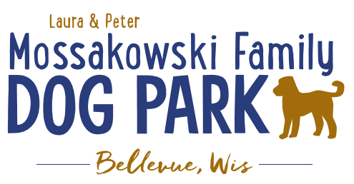
Laura and Peter Mossakowski Family Dog Park, LTD Committee Meeting

Date & Location: December 2, 2020 9:15a @ Laura Mossakowski LLC (2555 Continental Dr.; Green Bay, WI 54311)

Meeting Began:

In attendance:

VP Report:
Approval of November minutes:

Treasurer Report:
Current Balance: $___________ ($_____________est. total with Village Account)
Village Account Update: $12,594 from Fall 2020 update
Village Known outstanding bills include:
Outstanding Bills: Mr. Doody Pet Waste Service, Tax return
Incoming Donations:

Secretary Report:
No updates

Community Fundraising:
Grant Writing
Adam and Erin

Memorial fundraisers – small gardens, rocks and other structures, plaques, benches, etc.
Donn @ Forever Friends has rock options that can be looked into (examples available for next in person meeting) – stones not meant to be walked on but meant for outdoor display
Fine tune details, location, and pricing for future meeting
Bricks starting at $200 unless lower cost option found
Memorial benches also – Starting at $2500; hydrant starting at $5,000
Memorial options on other benches and small plaques on the shade structure

Sample brick gotten, laser printed, may be allow a lower cost option but want to be sure it is sturdy – min $100 to purchase– Test brick at the park

An additional brick company was found by way of another area fundraiser, looking into

A few hydrants to be installed and plaques made; $2500+ Fire hydrants or memorial boulders
Slabs poured, ready for hydrants – Parks to install

DNR funding / grants: Adam to help work on planning for upcoming grants and funds that can be used for ongoing projects 2021 grant application for 2022 projects (board walk and bridge as goals) – also looking to get Allouez involved to get the application going

Old Business:
Construction & Maintenance Updates:
Shade Structure in Small Dog Area
Adam working with a few companies to get other ideas for structures that may be better for planning and designs for what we are looking for

Adam meeting with Lizer to go over mowing and landscaping plan for 2021, looking to help the muddy areas as well

Next Meeting Dates:______________(9:15am at Laura Mossakowski LLC; 2555 Continental Dr., Green Bay OR Zoom teleconference meeting)

2021 Annual Committee Board Meeting to follow January 2021 meeting

New Business:
Discuss 2021 and beyond maintenance plan per contract

If not already done, choose winners for scavenger hunt and post to FaceBook

Meeting Adjourned:

