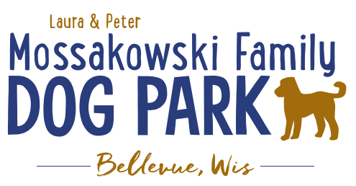
Laura and Peter Mossakowski Family Dog Park, LTD Committee Meeting

Date & Location: January 24, 2021 @ 9:15a @ Laura Mossakowski LLC (2555 Continental Dr.; Green Bay, WI 54311)

Meeting Began:

In attendance:

VP Report:
Approval of January minutes:

Treasurer Report:
Current Balance: $______________ ($_____________ est. total with Village Account)
Village Account Update: $13,593 from December 2020 update
Village Known outstanding bills include: portapotty rental for last few months
Outstanding Bills:
Incoming Donations:

Secretary Report:

Community Fundraising:
Grant Writing

Memorial fundraisers – small gardens, rocks and other structures, plaques, benches, etc.
Donn @ Forever Friends has rock options that can be looked into
Fine tune details, location, and pricing for future meeting
Bricks starting at $200 unless lower cost option found
Memorial benches also – Starting at $2500; hydrant starting at $5,000
Memorial options on other benches and small plaques on the shade structure

Sample brick gotten, laser printed, may be allow a lower cost option but want to be sure it is sturdy – min $100 to purchase – Testing a brick at the park

An additional brick company was found by way of another area fundraiser, looking into

A few hydrants to be installed and plaques made; $2500+ Fire hydrants or memorial boulders
Slabs poured, ready for hydrants – Parks to install
Memorial plaque needed for Malley’s hydrant (Office Sign Company can be looked into – outdoor safe?)

DNR funding / grants: Adam to help work on planning for upcoming grants and funds that can be used for ongoing projects 2021 grant application for 2022 projects (board walk and bridge as goals) – also looking to get Allouez involved to get the application going
Condos want to expand and get connected to East River trail as well
Adam started applications last week, letter of support and help from Allouez being sought

Old Business:
Construction & Maintenance Updates:
Shade Structure in Small Dog Area
Co-Op quote: shelter material is $9,300 + $15,412 for install from this vendor = ~$25K + the cost of a concrete pad = total cost of the project (without getting other quotes)
Updates:

Adam meeting with Lizer to go over mowing and landscaping plan for 2021, looking to help the muddy areas as well

Damage to posts, dog bag dispenser, and fee box – may have been damaged by the Village crew, looking into the repairs for the spring
Pass along any damage when noted so if it was caused by contractors

Little Free Library being built – consider some stone path around it to prevent mowing from needing to be done right around post

Next Meeting Dates: __________, 2021 (9:15am at Laura Mossakowski LLC; 2555 Continental Dr., Green Bay OR Zoom teleconference meeting)

New Business:
June 26th, 2021 – Dog Park Birthday Party – Josten Park (currently on hold for us, if dates need to change need to let Adam know ASAP)
Lead Organizer:
Thoughts for the event: Raffles?, Use of the main pavilion in the park rather than just the open air one?, food?, Beer vendors?, time for the event?, etc.

Meeting Adjourned:

