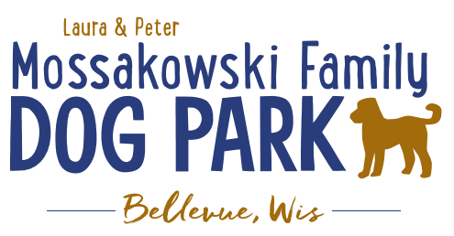
Laura and Peter Mossakowski Family Dog Park, LTD Committee Meeting

Date & Location: March 15, 2021 @ 9:15a @ Laura Mossakowski LLC (2555 Continental Dr.; Green Bay, WI 54311)

Meeting Began: 9:15a

In attendance: Erin Mader, Mark Schuster, Laura Mossakowski, Paul Theys, Adam Waszak, Kyle Casper, Jennie Wertel

VP Report:
Approval of February minutes: Paul, Jennie

Treasurer Report:
Current Balance: $29,324 ($16,084.78est. total with Village Account)
Outstanding Bills: $600 & Website fee
Incoming Donations: $500 LPL match donation

Secretary Report:

Community Fundraising:
Grant Writing– Erin is looking into more opportunities that may be available this summer and she will apply to them when applicable

Memorial fundraisers – small gardens, rocks and other structures, plaques, benches, etc.
Donn @ Forever Friends has rock options that can be looked into
Fine tune details, location, and pricing for future meeting
Bricks starting at $200 unless lower cost option found
Memorial benches also – Starting at $2500; hydrant starting at $5,000
Memorial options on other benches and small plaques on the shade structure

Sample brick gotten, laser printed, may be allow a lower cost option but want to be sure it is sturdy – min $100 to purchase– Testing a brick at the park

An additional brick company was found by way of another area fundraiser, looking into

A few hydrants to be installed and plaques made; $2500+ Fire hydrants or memorial boulders
Slabs poured, ready for hydrants – Parks to install
Memorial plaque needed for Malley’s hydrant (Office Sign Company can be looked into – outdoor safe?)

DNR funding / grants: Adam to help work on planning for upcoming grants and funds that can be used for ongoing projects 2021 grant application for 2022 projects (board walk and bridge as goals) – also looking to get Allouez involved to get the application going
Condos want to expand and get connected to East River trail as well
Adam started applications and seeking documents needed

Old Business:
Construction & Maintenance Updates:
Shade Structure in Small Dog Area
Co-Op quote: shelter material is $9,300 + $15,412 for install from this vendor = ~$25K + the cost of a concrete pad = total cost of the project.
Updates: Adam is looking to see if a licensed contractor is needed. If not, there are likely more options and at lower costs to fit the needs. Adam, Mark and Erin are looking into get other quotes.
Waiting on a few quotes, hopefully to have some in the coming weeks

Damage to fee box – the original creator will not replace it but Wayne-metals instructor with NWTC/his class will rebuild it at only the cost of the materials –great! They already did a different one for another park that was modeled off the original one at our park. $110 cost of materials – great option!
Pass along any damage when noted so if it was caused by contractors

Little Free Library being built by Paul – finished and waiting to install

June 26th, 2021 – Dog Park Birthday Party – Josten Park
Lead Organizer: Erin Mader
Thoughts for the event: Raffles?, Use of the main pavilion in the park rather than just the open air one?, food?, Beer vendors?, time for the event?, Lure Course, etc.

Next Meeting Dates:Wednesday, April 28th, 2021(9:15am at Laura Mossakowski LLC; 2555 Continental Dr., Green Bay OR Zoom meeting)

New Business:
Suggestion for having a rentable area of the dog park, at this time that will be difficult, though the thought is understandable the current set up doesn’t allow for it

PayPal Dog Park QR Code – for donations, put some laminated copies out at the park

Consider another scavenger hunt at the park in the coming months

In the coming weeks the holes will get fenced off and reseeded to help the muddy areas, may need to reseed around the water area too

Meeting Adjourned: 9:40a

