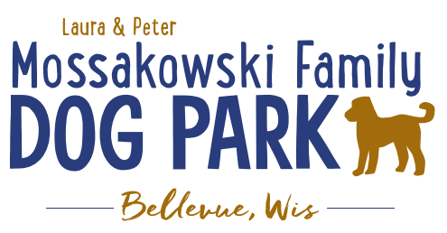
Laura and Peter Mossakowski Family Dog Park, LTD Committee Meeting

Date & Location: April 28, 2021 @ 9:15a @ Laura Mossakowski LLC (2555 Continental Dr.; Green Bay, WI 54311)

Meeting Began: 0915

In attendance: Laura Mossakowski, Paul Theys, Erin Mader, Adam Waszak, Jennie Wertel
VP Report:
Approval of March Minutes: Paul, Laura

Treasurer Report:
Current Balance: $29,593 ($45,678est. total with Village Account)
Outstanding Bills: none known
Incoming Donations:

Secretary Report:

Community Fundraising:
Grant Writing– Erin is looking into more opportunities that may be available this summer and she will apply to them when applicable

Memorial fundraisers – small gardens, rocks and other structures, plaques, benches, etc.
Donn @ Forever Friends has rock options that can be looked into
Fine tune details, location, and pricing for future meeting
Bricks starting at $200 unless lower cost option found
Memorial benches also – Starting at $2500; hydrant starting at $5,000
Memorial options on other benches and small plaques on the shade structure

Sample brick gotten, laser printed, may be allow a lower cost option but want to be sure it is sturdy – min $100 to purchase– Testing a brick at the park

An additional brick company was found by way of another area fundraiser, looking into

A few hydrants to be installed and plaques made; $2500+ Fire hydrants or memorial boulders
Slabs poured, ready for hydrants – Parks to install
Memorial plaque ready for Malley’s hydrant
Small Dog Area plaque still available for sponsorship/donation – requested minimum of

DNR funding / grants: Adam to help work on planning for upcoming grants and funds that can be used for ongoing projects 2021 grant application for 2022 projects (board walk and bridge as goals) – also looking to get Allouez involved to get the application going
Condos want to expand and get connected to East River trail as well
Adam getting documents sent out

Old Business:
Construction & Maintenance Updates:
Shade Structure in Small Dog Area
Co-Op quote: shelter material is $9,300 + $15,412 for install from this vendor = ~$25K + the cost of a concrete pad = total cost of the project.
Updates: Adam is looking to see if a licensed contractor is needed. If not, there are likely more options and at lower costs to fit the needs. Adam, Mark and Erin are looking into get other quotes.
Immel Construction: $17,800 for installation of the pre-purchased shelter
Potentially reaching out to others for install quotes as well

Little Free Library being built by Paul – finished and installed! – books needed

June 26th, 2021 – Dog Park Birthday Party – Josten Park
Lead Organizer: Erin Mader
11a-3pm time
Booth vendors are signing up! – looks like 4 confirmed booths and a few additional possibilities, seeking more booth vendors, Dog Park Booth with beverages and baked items
Jennie to help with food – food truck (The Dog House), baked goods booth with beverages from the dog park, consider local brewery to have a booth, Dog Friendly Items
Laura to help with raffles – looking to see if there are raffle donations

Volunteers Needed! – searching for options to help out

Activities – Lure Course, Activity Booths (temporary tattoos and other low contact options), Demos (Police K9, Scent Dogs, Sled Dogs, etc.), +/- Bounce House, Costume and Trick Contests,

Help needed to install new agility ramp – looking to install this weekend

Next Meeting Dates:Wednesday, May 19th, 2021(9:15am at Laura Mossakowski LLC; 2555 Continental Dr., Green Bay OR Zoom meeting)

New Business:
Consider another scavenger hunt at the park in the coming months – on hold for now

Shade structures going up and water going on first week in May!

Fencing off some low areas and over-seed areas needed

Potentially look at adding a few more hydrants if able

Meeting Adjourned: 1010

