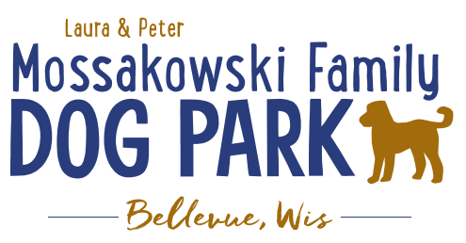
Laura and Peter Mossakowski Family Dog Park, LTD Committee Meeting

Date & Location: April 28, 2021 @ 9:15a @ Laura Mossakowski LLC (2555 Continental Dr.; Green Bay, WI 54311)

Meeting Began:

In attendance:
VP Report:
Approval of March Minutes:

Treasurer Report:
Current Balance: $___________ ($_____________est. total with Village Account)
Outstanding Bills:
Incoming Donations:

Secretary Report:

Community Fundraising:
Grant Writing– Erin is looking into more opportunities that may be available this summer and she will apply to them when applicable

Memorial fundraisers – small gardens, rocks and other structures, plaques, benches, etc.
Donn @ Forever Friends has rock options that can be looked into
Fine tune details, location, and pricing for future meeting
Bricks starting at $200 unless lower cost option found
Memorial benches also – Starting at $2500; hydrant starting at $5,000
Memorial options on other benches and small plaques on the shade structure

Sample brick gotten, laser printed, may be allow a lower cost option but want to be sure it is sturdy – min $100 to purchase– Testing a brick at the park

An additional brick company was found by way of another area fundraiser, looking into

A few hydrants to be installed and plaques made; $2500+ Fire hydrants or memorial boulders
Slabs poured, ready for hydrants – Parks to install
Memorial plaque ready for Malley’s hydrant

DNR funding / grants: Adam to help work on planning for upcoming grants and funds that can be used for ongoing projects 2021 grant application for 2022 projects (board walk and bridge as goals) – also looking to get Allouez involved to get the application going
Condos want to expand and get connected to East River trail as well
Adam started applications and seeking documents needed

Old Business:
Construction & Maintenance Updates:
Shade Structure in Small Dog Area
Co-Op quote: shelter material is $9,300 + $15,412 for install from this vendor = ~$25K + the cost of a concrete pad = total cost of the project.
Updates: Adam is looking to see if a licensed contractor is needed. If not, there are likely more options and at lower costs to fit the needs. Adam, Mark and Erin are looking into get other quotes.
Immel Construction: $17,800 for installation of the pre-purchased shelter

Little Free Library being built by Paul – finished and installed!

June 26th, 2021 – Dog Park Birthday Party – Josten Park
Lead Organizer: Erin Mader
Thoughts for the event: Raffles?, Use of the main pavilion in the park rather than just the open air one?, food?, Beer vendors?, time for the event?, Lure Course, etc.
Booth vendors are signing up!

Help needed to install new agility ramp

Next Meeting Dates:Wednesday, _____________, 2021(9:15am at Laura Mossakowski LLC; 2555 Continental Dr., Green Bay OR Zoom meeting)

New Business:
Consider another scavenger hunt at the park in the coming months

In the coming weeks the holes will get fenced off and reseeded to help the muddy areas, may need to reseed around the water area too

Meeting Adjourned:

