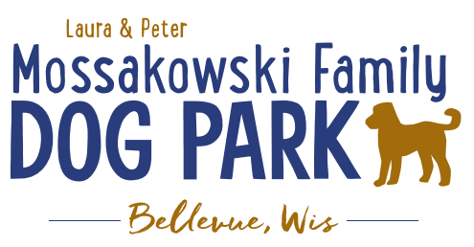
Laura and Peter Mossakowski Family Dog Park, LTD Committee Meeting

Date & Location: 6/23/2021 @ 9:15a @ Laura Mossakowski LLC (2555 Continental Dr.; Green Bay, WI 54311)

Meeting Began:

In attendance:

VP Report:
Approval of May Minutes:

Treasurer Report:
Current Balance: $_____________($_________est. total with Village Account)
Outstanding Bills: none
Incoming Donations: Paypal, Amazon, etc. sent in donations

Secretary Report:

Community Fundraising:
June 26th, 2021 – Dog Park Birthday Party – Josten Park
Lead Organizer: Erin Mader
11a-3pm time
Booth vendors are signing up! – looks like 6+ confirmed booths and a few additional possibilities, seeking more booth vendors, Dog Park Booth with beverages and baked items, GVAH booth
Jennie to help with food – food truck (The Dog House), baked goods booth with beverages from the dog park, consider local brewery to have a booth, Dog Friendly Items
The Dog House food truck – needs flat solid ground for truck
Badger State Brewery – needs power, flat solid ground
Laura to help with raffles – looking to see if there are raffle donations

Volunteers Needed! –10 volunteers signed up for event in addition to the current committee team!

Activities – Lure Course, Activity Booths (temporary tattoos and other low contact options), Demo (Police K9), Bounce House, Costume and Trick Contests w/prizes,

Toni to possibly MC for the event

10:00a meeting for the day with all vendors and volunteers

Discuss brief run through of what the day will look like (time to arrive, meeting time, time for events, etc.)

Next Meeting Dates:July 28th, 2021 (9:15am at Laura Mossakowski LLC; 2555 Continental Dr., Green Bay OR Zoom meeting)

Meeting Adjourned:

