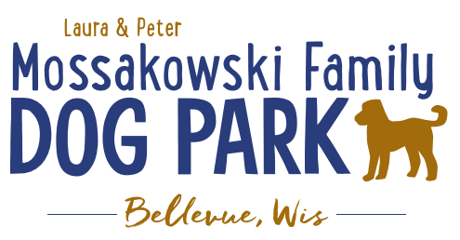
Laura and Peter Mossakowski Family Dog Park, LTD Committee Meeting

Date & Location: 6/9/2021 @ 9:15a @ Laura Mossakowski LLC (2555 Continental Dr.; Green Bay, WI 54311)

Meeting Began: 9:15am

In attendance: Paul Theys, Laura Mossakowski, Jennie Wertel, Erin Mader

VP Report:
Approval of May Minutes: Paul, Laura

Treasurer Report:
Current Balance: $30,163.03 ($_________ est. total with Village Account)
Outstanding Bills: none
Incoming Donations: Paypal, Amazon, etc. sent in donations

Secretary Report:

Community Fundraising:
Grant Writing – Erin is looking into more opportunities that may be available this summer and she will apply to them when applicable

*Tabled until future meeting after birthday party* Memorial fundraisers – small gardens, rocks and other structures, plaques, benches, etc.
Donn @ Forever Friends has rock options that can be looked into
Fine tune details, location, and pricing for future meeting
Bricks starting at $200 unless lower cost option found
Memorial benches also – Starting at $2500; hydrant starting at $5,000
Memorial options on other benches and small plaques on the shade structure

Sample brick gotten, laser printed, may be allow a lower cost option but want to be sure it is sturdy – min $100 to purchase – Testing a brick at the park

An additional brick company was found by way of another area fundraiser, looking into

A few hydrants to be installed and plaques made; $2500+ Fire hydrants or memorial boulders
Slabs poured, ready for hydrants – Parks to install, needing a base for the smaller one before installation
Memorial plaque ready for Malley’s hydrant
Small Dog Area plaque still available for sponsorship/donation – requested minimum of $1500

DNR funding / grants: Adam to help work on planning for upcoming grants and funds that can be used for ongoing projects 2021 grant application for 2022 projects (board walk and bridge as goals) – also looking to get Allouez involved to get the application going
Condos want to expand and get connected to East River trail as well
Adam getting documents sent out

Old Business:
Construction & Maintenance Updates:
Shade Structure in Small Dog Area
Co-Op quote: shelter material is $9,300 + $15,412 for install from this vendor = ~$25K + the cost of a concrete pad = total cost of the project.
Updates: Adam is looking to see if a licensed contractor is needed. If not, there are likely more options and at lower costs to fit the needs. Adam, Mark and Erin are looking into get other quotes.
Immel Construction: $17,800 for installation of the pre-purchased shelter
Potentially reaching out to others for install quotes as well

Little Free Library being built by Paul – finished and installed! – seems to be going well, keep adding books

June 26th, 2021 – Dog Park Birthday Party – Josten Park
Lead Organizer: Erin Mader
11a-3pm time
Booth vendors are signing up! – looks like 6+ confirmed booths and a few additional possibilities, seeking more booth vendors, Dog Park Booth with beverages and baked items, GVAH booth
Jennie to help with food – food truck (The Dog House), baked goods booth with beverages from the dog park, consider local brewery to have a booth, Dog Friendly Items
The Dog House food truck – needs flat solid ground for truck
Badger State Brewery – needs power, flat solid ground
Laura to help with raffles – looking to see if there are raffle donations

Volunteers Needed! –10 volunteers signed up for event in addition to the current committee team!

Activities – Lure Course, Activity Booths (temporary tattoos and other low contact options), Demo (Police K9), Bounce House, Costume and Trick Contests w/prizes,

Toni to possibly MC for the event

10:00a meeting for the day with all vendors and volunteers

Next Meeting Dates: June 23rd, 2021 (9:15am at Laura Mossakowski LLC; 2555 Continental Dr., Green Bay OR Zoom meeting) & July 28th, 2021 will be the following

New Business:
Consider another scavenger hunt at the park in the coming months – on hold for now

Meeting Adjourned: 10:15a

