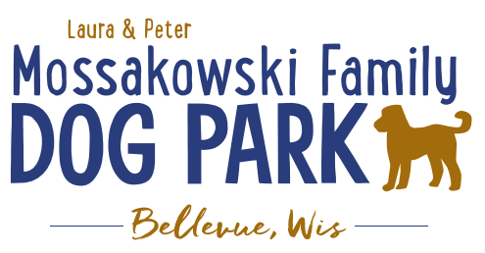
Laura and Peter Mossakowski Family Dog Park, LTD Committee Meeting

Date & Location: 7/28/2021 @ 9:15a @ Laura Mossakowski LLC (2555 Continental Dr.; Green Bay, WI 54311)

Meeting Began: 9:15a

In attendance: Paul Theys, Laura Mossakowski, Jennie Wertel, Adam Waszak, Pete Mossakowski

Community Fundraising:
SUNDAY, August 15th, 2021 – Dog Park Birthday Party – Josten Park
Lead Organizer: TEAM EFFORT / Pete
11a-3pm time
Booth vendors update:
Jennie to help with food – food truck (Gourmet Corn), baked goods booth with beverages from the dog park, Badger State Brewery, Dog Friendly Items

Volunteer number: 4 plus committee, and LJ; will need to email responsibilities and details closer to the event
Bounce house
Lure course
Check In
Activities

Activities – Lure Course, Activity Booths (temporary tattoos and other low contact options), Demo (Police K9) 11a-1p sometime, Bounce House, Costume and Trick Contests w/prizes,

Toni to MC for the event

10:00a meeting for the day with all vendors and volunteers - Discuss brief run through of what the day will look like (time to arrive, meeting time, time for events, etc.)

Next Meeting Dates: Wednesday, September 1st (9:15am at Laura Mossakowski LLC; 2555 Continental Dr., Green Bay OR Zoom meeting)

Meeting Adjourned: 9:50a

