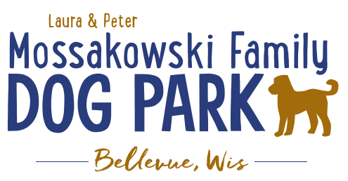
Laura and Peter Mossakowski Family Dog Park, LTD Committee Meeting

Date & Location: 10/13/2021 @ 9:15a @ Laura Mossakowski LLC (2555 Continental Dr.; Green Bay, WI 54311)

Meeting Began: 9:15am

In attendance: Laura Mossakowski, Adam Waszak, Paul Theys, Jennie Wertel

VP Report:
Approval of September Minutes: Paul, Laura

Treasurer Report:
Current Balance: $33,889 ($~46,000 est. total with Village Account)
Outstanding Bills: none
Incoming Donations: PayPal, Venmo, Laura & Pete’s Donation with company match

Secretary Report: no updates

Community Fundraising:
Grant Writing – looking for someone to help in this department

Memorial fundraisers – step 1 is to know where they would be going, any thoughts?
small gardens, rocks and other structures, plaques, benches, etc.
Donn @ Forever Friends has rock options that can be looked into
Fine tune details, location, and pricing when details known
Bricks starting at $200 unless lower cost option found

Benches and Table Memorials can have plaque memorials added – requested minimum of $2500

Memorial plaque on Little Free Library option

A few hydrants to be installed and plaques made; $2500+ Fire hydrants or memorial boulders
Small Dog Area plaque still available for sponsorship/donation – requested minimum of $2500

Options for signage to look for sponsorship from businesses, there have been signs up at other parks why can’t ours have that option – technically it violates the ordinance, if banners or signage are added consider it to be a risk that there is the possibility they may need to be taken down. Temporary signage is more of an issue than the permanent signs (with annual contract with annual fee).
$500/yr minimum for banner at other parks – only over a several month process, annual contract

DNR funding / grants: Adam to help work on planning for upcoming grants and funds that can be used for ongoing projects 2021 grant application for 2022 projects (board walk and bridge as goals) – No Bellevue projects accepted

DOT Tap Grant a possible option – trail system/alternate transportation (Due Jan 2022) – Adam and Mark

Old Business:
Construction & Maintenance Updates:
Shade Structure in Small Dog Area – consider another rebid to see if costs have come down and there may be another option for 2021 yet, 2022 is the next opportunity for a Packers grant option but we need that project done
Co-Op quote: shelter material is $9,300 + $15,412 for install from this vendor = ~$25K + the cost of a concrete pad = total cost of the project.
Updates: Consider another request for assistance from the Village, update quote from previous company, Meet with Park Committee December 13th & Village Board January 12th.

Landscaping boulders to be placed along parking lot to deter parking on the grass

Next Meeting Dates: December 1st, 2021 (9:15am at Laura Mossakowski LLC; 2555 Continental Dr., Green Bay OR Zoom meeting) (January 5th, 2022 with Annual Board Meeting to follow for future dates as we plan presentations)

New Business:
Consider starting an annual semi-annual report to the Village Board with a formal presentation of donations and progress at the park – highlight that we have been able to maintain the park and it is the most highly trafficked park, highlight big picture of the park with goals, highlight feedback from users, etc. Highlight the importance of working together for the park completion. – Consider Dec 13th and Jan 12th presentations
Pull info on where our pass holders are from, numbers, incoming funds from passes and donations, feedback from visitors, pictures from visitors, comments from donors, criticisms that have been fixed, show that improvements were always in the plan and the community is looking forward to it, etc.

Water fountain will be winterized for year in the next week or two (Oct 18-25th based on schedule and weather)

Meeting Adjourned: 10:05am

