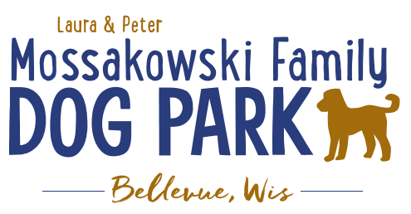
Laura and Peter Mossakowski Family Dog Park, LTD Committee Meeting

Date & Location: 10/13/2021 @ 9:15a @ Laura Mossakowski LLC (2555 Continental Dr.; Green Bay, WI 54311)

Meeting Began:

In attendance:

VP Report:
Approval of September Minutes:

Treasurer Report:
Current Balance: $___________ ($~___________ est. total with Village Account)
Outstanding Bills: none
Incoming Donations: looking for a match donation from a local business

Secretary Report: no updates

Community Fundraising:
Grant Writing – looking for someone to help in this department

Memorial fundraisers – step 1 is to know where they would be going, any thoughts?
small gardens, rocks and other structures, plaques, benches, etc.
Donn @ Forever Friends has rock options that can be looked into
Fine tune details, location, and pricing when details known
Bricks starting at $200 unless lower cost option found

Benches and Table Memorials can have plaque memorials added – requested minimum of $2500

Memorial plaque on Little Free Library option

A few hydrants to be installed and plaques made; $2500+ Fire hydrants or memorial boulders
Small Dog Area plaque still available for sponsorship/donation – requested minimum of $2500

Options for signage to look for sponsorship from businesses, there have been signs up at other parks why can’t ours have that option

DNR funding / grants: Adam to help work on planning for upcoming grants and funds that can be used for ongoing projects 2021 grant application for 2022 projects (board walk and bridge as goals) – any updates?

Old Business:
Construction & Maintenance Updates:
Shade Structure in Small Dog Area – consider another rebid to see if costs have come down and there may be another option for 2021 yet, 2022 is the next opportunity for a Packers grant option but we need that project done
Co-Op quote: shelter material is $9,300 + $15,412 for install from this vendor = ~$25K + the cost of a concrete pad = total cost of the project.
Updates:

Next Meeting Dates: _________ (9:15am at Laura Mossakowski LLC; 2555 Continental Dr., Green Bay OR Zoom meeting)

New Business:

Meeting Adjourned:

