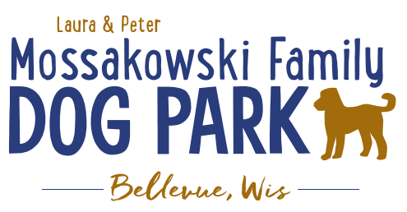
Laura and Peter Mossakowski Family Dog Park, LTD Committee Meeting

Date & Location: 02/02/2022 @ 9:15a @ Laura Mossakowski LLC (2555 Continental Dr.; Green Bay, WI 54311)

Meeting Began:

In attendance:

VP Report:
Approval of December Minutes:

Treasurer Report:
Current Balance: $__________ (~$_________ est. total with Village Account)
Outstanding Bills:
Incoming Donations:

Secretary Report: no updates

Community Fundraising:
Grant Writing – looking for someone to help in this department
Packers Grant 2022 – Open from May 1 – July 1 (consider next grant to be towards boardwalks or kayak launch)

(Ongoing Topic) Memorial fundraisers – step 1 is to know where they would be going, any thoughts?
small gardens, rocks and other structures, plaques, benches, etc.
Donn @ Forever Friends has rock options that can be looked into
Fine tune details, location, and pricing when details known
Bricks starting at $200 unless lower cost option found

Benches and Table Memorials can have plaque memorials added – requested minimum of $2500

Memorial plaque on Little Free Library option

A few hydrants to be installed and plaques made; $2500+ Fire hydrants or memorial boulders
Small Dog Area plaque still available for sponsorship/donation – requested minimum of $2500
Looking to add two more hydrants, one will be spoken for

Possibly looking to add in more fire hydrants based on availability as they are replaced in the village

Options for signage to look for sponsorship from businesses
$500 / 6 months minimum for banner at other parks – over a several month period (Jan-June & July-December based on weather or damage),
Semi-annual Contract, choose large dog area, small dog area, or no preference
Description that the banners are going to be located inside the dog park fencing and that the funds are going directly to the dog park as a 501(c)3 group and is tax deductible
The business provides the signs and if replacement is needed they can choose to do so or not
Consider Spring / Summer 2022 addition for the park
Look at the already existing doc from the village to adapt it to the park and work with the parks department to get the word out in their January letter to Bellevue businesses

DOT Tap Grant a possible option – trail system/alternate transportation (Due Jan 2022) – Adam working on it

Old Business:
Village Board presentation and proposal for funding was well received, funding for up to $20,000 was granted to try to finish the small dog shade structure before May 1.

Construction & Maintenance Updates:
Shade Structure in Small Dog Area – 2022 is the next opportunity for a Packers grant option but we need that project done in order to be eligible for any additional grants
Updates:

Eagle Scout Project (Paul Goral): To build a 4-Legged Ramp for the dog park; plans to be approved and finalized by Park Commission (Plan to have it complete by June)

Next Meeting Dates: 9:15am Wednesday, _________________, 2022 @ Laura Mossakowski LLC (or via zoom)

New Business:
Sandy Kemper from OVAH – updates on clean up at the park as well as stocking of dog waste bags
Addition of dog waste stations?

Meeting Adjourned:

