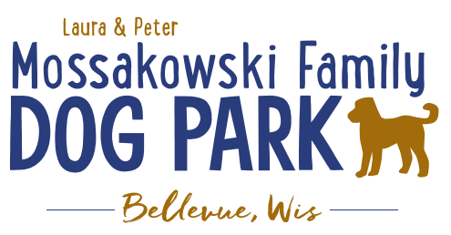
Laura and Peter Mossakowski Family Dog Park, LTD Committee Meeting

Date & Location: 6/1/2022 @ 9:15a @ Laura Mossakowski LLC (2555 Continental Dr.; Green Bay, WI 54311)

Meeting Began: 9:10am

In attendance: Laura Mossakowski, Paul Theys, Adam Waszak, Jennie Wertel

VP Report:
Approval of April Minutes: Laura, Paul

Treasurer Report:
Current Balance: $41,762 (~$ __________ est. total with Village Account)
Outstanding Bills: Shade Structure $35,000-37,000 – TBD when shipped/installed
Incoming Donations: a matching donation through Grainger

Secretary Report: no updates

Community Fundraising:
Grant Writing – looking for someone to help in this department
Packers Grant 2022 – Open from May 1 – July 1 (consider next grant to be towards boardwalks or kayak launch, covered entry way)
Only eligible if shade structure is complete – as of last week the product hasn’t been received
Cost of proposed project?
Photos of proposed project?
Number of people potentially impacted by project?
Benefits to the community & park goers?

(Ongoing Topic) Memorial fundraisers – step 1 is to know where they would be going, any thoughts?
small gardens, rocks and other structures, plaques, benches, etc.
Donn @ Forever Friends has rock options that can be looked into
Fine tune details, location, and pricing when details known
Bricks starting at $200 unless lower cost option found

Benches and Table Memorials can have plaque memorials added – requested minimum of $2500

Memorial plaque on Little Free Library option, plaques on the agility equipment – starting at $100 (based on the cost of materials, size, and location)

A few hydrants to be installed and plaques made; $2500+ Fire hydrants or memorial boulders
Small Dog Area plaque still available for sponsorship/donation – requested minimum of $2500
Looking to add two more hydrants, one will be spoken for

Possibly looking to add in more fire hydrants based on availability as they are replaced in the village – at this time smaller hydrants are being replaced and can be held for the park

Consider adding in a plaque/memorial option when we know if there will be a shaded entry way into the parks

Options for signage to look for sponsorship from businesses - $500 / 6 months minimum for banner at other parks – over a several month period (Jan-June & July-December based on weather or damage), Signs starting to be hung up
Consider sending the vendors from our last event lists

Old Business:
Waste Cleanup still an issue – push for more self-policing

Amendment to the Committee-Village agreement to include an end date to help ensure that the fees that are collected for the park stay with the park

Construction & Maintenance Updates:
Shade Structure in Small Dog Area – 2022 is the next opportunity for a Packers grant option but we need that project done in order to be eligible for any additional grants
Updates: Looking at location for shelter that will allow it to be ADA accessible and have a path from the gate

Minnesota and Wisconsin Playgrounds – final cost not determined until it is shipped. Currently between $35,000-$37,000 final cost but needing to know shipment date
Permits figured out and just pending on weather and shipping

Eagle Scout Project (Paul Goral): To build a 4-Legged Ramp for the dog park – approved and will be building it soon

Next step for focus is potentially looking at the kayak launch, boardwalks, and shaded entry ways
Considerations – getting access to the water, making it a structure accessible for all, parking expansion, etc.

Next Meeting Dates: Wednesday, July 20th, 2022 @ 9:15a @ Laura Mossakowski LLC (or via zoom)

New Business:

Meeting Adjourned: 9:40am

