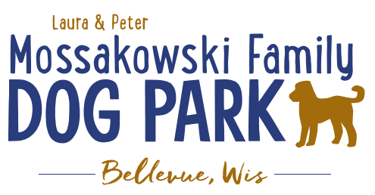
Laura and Peter Mossakowski Family Dog Park, LTD Committee Meeting

Date & Location: 8/17/2022 @ 9:15a @ Laura Mossakowski LLC (2555 Continental Dr.; Green Bay, WI 54311)

Meeting Began:

In attendance:

VP Report:
Approval of June Minutes:

Treasurer Report:
Current Balance: $_____________(~$ __________ est. total with Village Account)
Outstanding Bills: Shade Structure $35,000-37,000 – TBD when shipped/installed
Incoming Donations: a matching donation through Grainger

Secretary Report:no updates

Community Fundraising:
Grant Writing– looking for someone to help in this department
Packers Grant 2022 – Submitted, expecting a phone interview if we make it to the next step
Can we add a sign with a photo and an update of the construction coming?

(Ongoing Topic) Memorial fundraisers – step 1 is to know where they would be going, any thoughts?
small gardens, rocks and other structures, plaques, benches, etc.
Donn @ Forever Friends has rock options that can be looked into
Fine tune details, location, and pricing when details known
Bricks starting at $200 unless lower cost option found

Do we consider setting up an area near the koiosk? How hard would it be to move in the future?

Benches and Table Memorials can have plaque memorials added – requested minimum of $2500

Memorial plaque on Little Free Library option, plaques on the agility equipment – starting at $100 (based on the cost of materials, size, and location)

A few hydrants to be installed and plaques made; $2500+ Fire hydrants or memorial boulders
Small Dog Area plaque still available for sponsorship/donation – requested minimum of $2500
Looking to add two more hydrants, one will be spoken for

Possibly looking to add in more fire hydrants based on availability as they are replaced in the village – at this time smaller hydrants are being replaced and can be held for the park

Consider adding in a plaque/memorial option when we know if there will be a shaded entry way into the parks

Options for signage to look for sponsorship from businesses- $500 / 6 months minimum for banner at other parks –over a several month period (Jan-June & July-December based on weather or damage), Signs starting to be hung up

Old Business:
Waste Cleanup still an issue?

Amendment to the Committee-Village agreement to include an end date to help ensure that the fees that are collected for the park stay with the park

Construction & Maintenance Updates:
Shade Structure in Small Dog Area – 2022 is the next opportunity for a Packers grant option but we need that project done in order to be eligible for any additional grants
Updates: Looking at location for shelter that will allow it to be ADA accessible and have a path from the gate

Minnesota and Wisconsin Playgrounds – final cost not determined until it is shipped. Currently between $35,000-$37,000 final cost but needing to know shipment date
Permits figured out and just pending on weather and shipping

Eagle Scout Project (Paul Goral): To build a 4-Legged Ramp for the dog park – approved and will be building it soon

Next step for focus is potentially looking at the kayak launch, boardwalks, and shaded entry ways
Considerations – getting access to the water, making it a structure accessible for all, parking expansion, etc.

Next Meeting Dates:____________________, 2022 @ 9:15a @ Laura Mossakowski LLC (or via zoom)

New Business:
Request for cutting long grass submitted

Meeting Adjourned:

