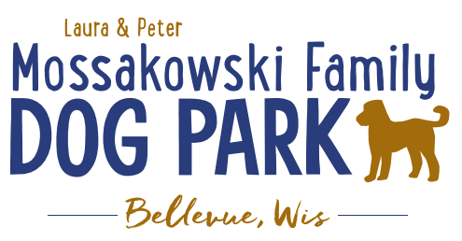
Board Meeting Minutes
January 11, 2023
Meeting Began:
Attendance:

Officer Election/Re-election – Motion to re-elect the following positions President, Vice President,&Treasurer
All in favor:
Opposed:

Current Board Members:
Laura Mossakowski – President
Paul Theys – Treasurer
Jennie Wertel – Vice President

Review of 2022 Meeting Minutes including prior January 11, 2023 meeting
Approved:
Opposed:

Review bylaws and confirm edits: no edits at this time
Approved:
Opposed:

2023 Focus:
Phase II Planning – priority focus on shade structure in small dog area, installation pending; also looking forward to the bridge, kayak launch, and trails

Fundraising Efforts – continue to raise funds to build out the master plan for the park

Committee Building – continue to build on the size of the committee to be able to continue to offer more dog friendly events and opportunities such as Yoga in the Park, etc.

Increase Social Media push for events and volunteers – goal is to increase people to come to events and awareness of park and increase the number of volunteers

Per the agreement with the Village the Committee is responsible for 0% of the maintenance where the Village is responsible for 100% for the 2023 calendar year

Seek amendment to the initial agreement to protect the park funds for the long term development of the dog park facility

Annual or Semi-annual updates to the Village Board to report on the “State of the Park” and help provide community feedback and continue to promote growth of the park

Meeting Adjourned:

