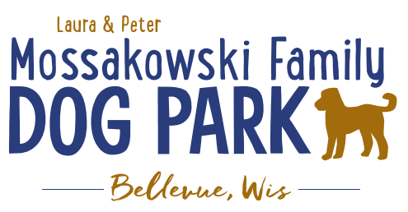
Laura and Peter Mossakowski Family Dog Park, LTD Committee Meeting

Date & Location: 2/8/2023 @ 9:15a @ Laura Mossakowski LLC (2555 Continental Dr.; Green Bay, WI 54311)

Meeting Began:

In attendance:

VP Report:
Approval of January Minutes: bill $19.99 domain name

Treasurer Report:
Current Balance: $_____54,903.04________(~$_37,000 est____________est. total with Village Account)
Outstanding Bills: Shade Structure $35,000-37,000 – TBD when shipped/installed
Incoming Donations:

Secretary Report:
Community Fundraising:
Grant Writing– looking for someone to help in this department

(Ongoing Topic) Memorial fundraisers – step 1 is to know where they would be going, any thoughts?
small gardens, rocks and other structures, plaques, benches, etc.; Consider a fund raiser campaign kick off for memorial options (bricks, benches, etc.) if location is decided

Benches and Table Memorials can have plaque memorials added – requested minimum of $2500

Memorial plaque on Little Free Library option, plaques on the agility equipment – starting at $100 (based on the cost of materials, size, and location)

A few hydrants to be installed and plaques made; $2500+ Fire hydrants or memorial boulders
Small Dog Area hydrant plaque still available for sponsorship/donation – requested minimum of $2500
Looking to add more hydrants, one will be spoken for (just to the right of the walk in)

Possibly looking to add in more fire hydrants based on availability as they are replaced in the village – at this time smaller hydrants are being replaced and can be held for the park

Consider adding in a plaque/memorial option when we know if there will be a shaded entry way into the parks

Sign sponsorship letters for 2023 going out

Old Business:
Amendment to the Committee-Village agreement to include an end date to help ensure that the fees that are collected for the park stay with the park – in development

Construction & Maintenance Updates:
Shade Structure in Small Dog Area – Installation plan

Eagle Scout Project (Paul Goral): To build a 4-Legged Ramp for the dog park – still fundraising

Next step for focus is potentially looking at the kayak launch, boardwalks, and shaded entry ways with opportunity for memorial plaques etc.
Additional Considerations – getting access to the water, making it a structure accessible for all, shaded pavilion in large dog area, natural play-scape area?, etc.
Much of the decision will be based on costs, Village participation of funding, and Grant options

Next Meeting Dates:_____________________@ 9:15a @ Laura Mossakowski LLC (or via zoom)

New Business:

Meeting Adjourned:

