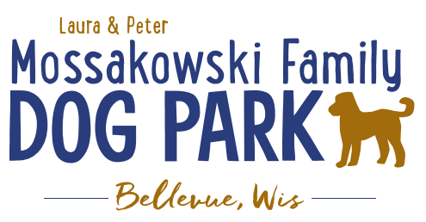
Laura and Peter Mossakowski Family Dog Park, LTD Committee Meeting

Date & Location: 7/19/2023 @ 9:15a @ Laura Mossakowski LLC (2555 Continental Dr.; Green Bay, WI 54311)

Meeting Began:

In attendance:

VP Report:
Approval of May Minutes:

Treasurer Report:
Current Balance: $___________(~$__________est. total with Village)
Outstanding Bills:
Incoming Donations:

Secretary Report:
Community Fundraising:
Grant Writing– looking for someone to help in this department

(Ongoing Topic) Memorial fundraisers – step 1 is to know where they would be going, any thoughts?
small gardens, rocks and other structures, plaques, benches, etc.; Consider a fund raiser campaign kickoff for memorial options (bricks, benches, etc.) if location is decided

Benches and Table Memorials can have plaque memorials added – requested minimum of $2500

Memorial plaque on Little Free Library option, plaques on the agility equipment – starting at $500 (based on the cost of materials, size, and location)

A few hydrants to be installed and plaques made; $2500+ Fire hydrants or memorial boulders
Small Dog Area hydrant plaque still available for sponsorship/donation – requested minimum of $2500

Possibly looking to add in more fire hydrants based on availability as they are replaced in the village – at this time smaller hydrants are being replaced and can be held for the park

Consider adding in a plaque/memorial option when we know if there will be a shaded entry way into the parks

Summer Parks Team to install a few more hydrants for additional memorial options

2024 DNR Grant Cycle – consider applications to help expand the park to the more inclusive full park for all (to do this there would need to be a plan in mind, amendment to the prev 5yr plan, and then apply to have most realistic chance)

2025 Parks Planning – Looking to add more dog park expansion ideas to help progression of those projects
Ensure inclusion in the Bellevue Comprehensive Outdoor Recreation Plan with the next 5yr plan coming in 2025, if needed to amend prev plan we can consider it but it will likely take many months to make that amendment and requires approval from Parks Committee and Board

Old Business:
Amendment to the Committee-Village agreement to include an end date to help ensure that the fees that are collected for the park stay with the park – in development

Low/muddy area just after entry gate into large dog area – solutions (fill it with something to help reduce that water retention area)

Look to meet with Dog Park Commission with update and discussion about future plans – Looking at updating in September when shade structure is complete (9/11/2023 – Parks Commission 6pm @ Village Hall; followed by the meeting for the Board)

Consider daily pass increase to $5/day/dog and Annual pass to increase in Jan 2024 – look at other parks in the area and then consider adjustment

Construction & Maintenance Updates:
Shade Structure in Small Dog Area – Installation plan – weather permitting the parks team will install it to save on costs

Eagle Scout Project (Paul Goral): To build a 4-Legged Ramp for the dog park – installed

Eagle Scout Project: New reach out, any suggestions? They mentioned agility equipment, is that needed at this time?

Next step for focus is potentially looking at a trail to the water and possibly a kayak launch, and shaded entry ways with opportunity for memorial plaques etc.
Additional Considerations – boardwalk +/- bridge in same project planning, getting access to the water w/kayak launch accessible for all, shaded pavilion in large dog area, natural play-scape area?, etc.
Much of the decision will be based on costs, Village participation of funding, and Grant options
Shaded Entry Way Thoughts – simple yet aesthetically pleasing, possibly concrete pad with memorial bricks along the edges, then look to expand that into the park to help with those low spots that develop with foot traffic

Next Meeting Dates:__________________@ 9:15a @ Laura Mossakowski LLC (or via zoom)

New Business:

Meeting Adjourned:

