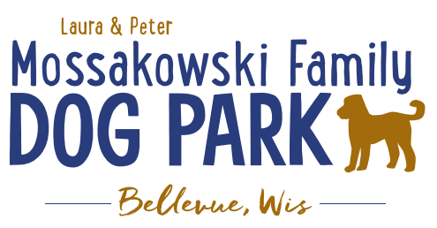
Laura and Peter Mossakowski Family Dog Park, LTD Committee Meeting

Date & Location: 10/11/2023 @ 9:15am @ Laura Mossakowski LLC (2555 Continental Dr.; Green Bay, WI 54311)

Meeting Began:

In attendance:

VP Report:
Approval of September Minutes:

Treasurer Report:
Current Balance: $_____________ (~$_____________ est. total with Village after bills pd)
Outstanding Bills:
Incoming Donations: park passes are still being sold; sign options still available, PayPal, Venmo

Secretary Report:
Community Fundraising:
Grant Writing – looking for someone to help in this department

(Ongoing Topic) Memorial fundraisers – step 1 is to know where they would be going, any thoughts?
small gardens, rocks and other structures, plaques, benches, etc.; Consider a fund raiser campaign kickoff for memorial options (bricks, benches, etc.) if location is decided

Benches and Table Memorials can have plaque memorials added – requested minimum of $2500

Memorial plaque on Little Free Library option, plaques on the agility equipment – starting at $500 (based on the cost of materials, size, and location)

A few hydrants to be installed and plaques made; $2500+ Fire hydrants or memorial boulders
Small Dog Area hydrant plaque still available for sponsorship/donation – requested minimum of $2500

Possibly looking to add in more fire hydrants based on availability as they are replaced in the village – at this time smaller hydrants are being replaced and can be held for the park

Consider adding in a plaque/memorial option when we know if there will be a shaded entry way into the parks

Summer Parks Team to install a few more hydrants for additional memorial options

2024 DNR Grant Cycle – consider applications to help expand the park to the more inclusive full park for all (to do this there would need to be a plan in mind, amendment to the prev 5yr plan, and then apply to have most realistic chance)

2025 Parks Planning – Continue to keep the dog park on the 5yr plan for the Village of Bellevue to continue to grow

Old Business:
Verification with new finance staff re: ensuring that the dog park pass fees stay with the dog park

Kiosk needs to be leveled out when able

Look to meet with the Village Board to give update and request to stay on the 5yr plan

Estimates for entry-way pavilions to consider for the future
Look at costs, installation, and color options

Construction & Maintenance Updates:
Shade Structure in Small Dog Area – Installation plan – weather permitting the parks team will install it to save on costs
- Due to be completed this week, or at the latest next week
- Fill in and reseed after

Eagle Scout Project (Sophie Gerondale):
- Thinking a small platform, ramp, and tunnel (2.5ft off the ground and 6ft by 6ft footprint)
- Looking for approval from Scout leaders/committee and the drafting of the plan before approval again

Next step for focus is potentially looking at a trail to the water and possibly a kayak launch, and shaded entry ways with opportunity for memorial plaques etc.
Additional Considerations – boardwalk +/- bridge in same project planning, getting access to the water w/kayak launch accessible for all, shaded pavilion in large dog area, natural play-scape area?, etc.
Much of the decision will be based on costs, Village participation of funding, and Grant options
Shaded Entry Way Thoughts – simple yet aesthetically pleasing, possibly concrete pad with memorial bricks along the edges, then look to expand that into the park to help with those low spots that develop with foot traffic (possibly start with predesigned option that we can add to and alter to fit our needs)

Next Meeting Dates: _____________________ @ 9:15a @ Laura Mossakowski LLC (or via zoom)

New Business:

Meeting Adjourned:

