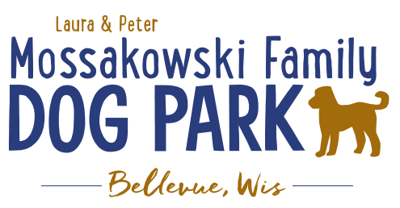
Board Meeting Minutes
January 10, 2024
Meeting Began:
Attendance:

Officer Election/Re-election – Motion to re-elect the following positions President, Vice President,&Treasurer
All in favor:
Opposed:

Current Board Members:
Laura Mossakowski – President
Jennie Wertel – Vice President
Paul Theys – Treasurer

Review of 2023 Meeting Minutes including prior January 10, 2024 meeting
Approved:
Opposed:

Review bylaws and confirm edits: no edits at this time
Approved:
Opposed:

2024 Focus:
Phase II Planning - looking forward to the bridge, kayak launch, and trails

Fundraising Efforts – continue to raise funds to build out the master plan for the park

Committee Building – continue to build on the size of the committee in order to be able to continue to offer more dog friendly events and opportunities such as Yoga in the Park, etc.

Increase Social Media push for events and volunteers – goal is to increase people to come to events and awareness of park and increase the number of volunteers

Continue the annual or semi-annual updates to the Village Board to report on the “State of the Park” and help provide community feedback and continue to promote growth of the park

Meeting Adjourned:

