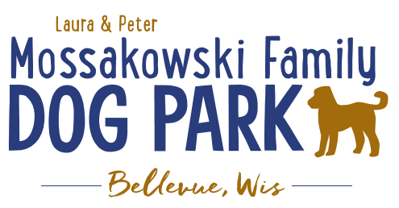

**Laura and Peter Mossakowski Family Dog Park, LTD Committee Meeting**

**Date & Location:** 5-15-2024 @ 9:15am @ Laura Mossakowski LLC (2555 Continental Dr.; Green Bay, WI 54311)

**Meeting Began:**

**In attendance:**

**VP Report:**

Approval of March Minutes:

**Treasurer Report:**

Current Balance: $_75388.54_($_2,262.22 __ est. total with Village after bills pd) $77650.76

Outstanding Bills: $160 bill for 990-N (Paid)

Incoming Donations:park passes are still being sold; sign options still available, PayPal, Venmo

**Secretary Report:**

**Community Fundraising:**

Grant Writing– looking for someone to help in this department

(Ongoing Topic) Memorial fundraisers – step 1 is to know where they would be going, any thoughts?

small gardens, rocks and other structures, plaques, benches, etc.; Consider a fund raiser campaign kickoff for memorial options (bricks, benches, etc.) if location is decided

Benches and Table Memorials can have plaque memorials added – requested minimum of $2500

Memorial plaque on Little Free Library option, plaques on the agility equipment – starting at $500 (based on the cost of materials, size, and location)

A few hydrants to be installed and plaques made; $2500+ Fire hydrants or memorial boulders

Small Dog Area hydrant plaque still available for sponsorship/donation – requested minimum of $2500

2024 DNR grants to be looked into, applications due 2024 (Trail Grants Due May 1 Annually)

Due to costs and constrictions from the Village Budget it is unlikely that any changes will be able to happen in the coming year or two; more likely goal is 2026-2027 but any possible village contributions won’t happen until 2028 if at all

*Important/Key goal: 2025 is when the next Village of Bellevue CORP (Bellevue Comprehensive Outdoor Recreation Plan) will be drafted, and it will include more advancements for the Dog Park as a way to help make Grant Applications stronger and continue to be include in the Village of Allouez future plans for ongoing planning*

Look at making the project break up in phases starting with the board walk from the existing dog park to the bridge site, then look at expanding from there if budgeting allows

Difficulty getting a quote that fits the budget due to the expenses of the trail

**Old Business:**

Kiosk needs to be leveled out when able – Spring 2024

Consider adding in a bag station in the central area of the park to help promote it if able – see how pick up goes for spring and decide

Raffle prize for those that purchased passes by a given date – raffle prize being collected; hold drawing and then consider holding another in the future

Watch the canopies for leaning as the ground thaws (in addition to the leaning of the Kiosk)

**Construction & Maintenance Updates:**

**Next Meeting Dates:**_______________@ 9:15a @ Laura Mossakowski LLC (or via zoom)

**New Business:**

Any thoughts on direction for a project given the estimates for the boardwalk/trail and shade structures over the last few months?

Would the boardwalk/trail project be an option if the village covered the maintenance trail that has been specified and is adding a substantial cost to the project?

Can the project be done in phases?

**Meeting Adjourned:**