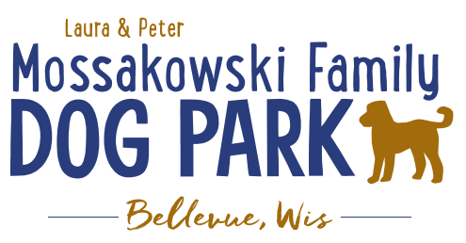

**Laura and Peter Mossakowski Family Dog Park, LTD Committee Meeting**

**Date & Location:** 8-7-2024 @ 9:15am @ Laura Mossakowski LLC (2555 Continental Dr.; Green Bay, WI 54311)

**Meeting Began: 9:15am**

**In attendance:Laura Mossakowski, Paul Theys, Jennie Wertel, Kyle Casper**

**VP Report:**

Approval of May Minutes:Laura, Paul

**Treasurer Report:**

Current Balance: $75,670 + $2,622 [prev meeting: $75,388.54($2622 est. total with Village after bills pd)]

Outstanding Bills:

Incoming Donations:park passes are still being sold; sign options still available, PayPal, Venmo

**Secretary Report:**

**Community Fundraising:**

Grant Writing– looking for someone to help in this department

(Ongoing Topic) Memorial fundraisers – step 1 is to know where they would be going, any thoughts?

small gardens, rocks and other structures, plaques, benches, etc.; Consider a fund raiser campaign kickoff for memorial options (bricks, benches, etc.) if location is decided

-Benches and Table Memorials can have plaque memorials added – requested minimum of $2500

-Memorial plaque on Little Free Library option, plaques on the agility equipment – starting at $500 (based on the cost of materials, size, and location)

-A few hydrants to be installed and plaques made; $2500+ Fire hydrants or memorial boulders

Small Dog Area hydrant plaque still available for sponsorship/donation – requested minimum of $2500

DNR grants - Trail Grants Due May 1 Annually

Due to costs and constrictions from the Village Budget it is unlikely that any changes will be able to happen in the coming year or two; more likely goal is 2026-2027 but any possible village contributions won’t happen until 2028 if at all

Begin to look at priority for the committee to continue to build out the master plan

* Consider doing smaller phases of the boardwalk to keep progress moving forward
* Consider pedestrian rated boardwalk initially, then expand as we are able and as we can continue to plan towards the bridge

***Important/Key goal****: 2025 is when the next Village of Bellevue CORP (Bellevue Comprehensive Outdoor Recreation Plan) will be drafted, and it will include more advancements for the Dog Park as a way to help make Grant Applications stronger and continue to be include in the Village of Allouez future plans for ongoing planning*

Look at making the project break up in phases starting with the board walk from the existing dog park to the bridge site, then look at expanding from there if budgeting allows

Difficulty getting a quote that fits the budget due to the expenses of the trail

**Old Business:**

Kiosk needs to be leveled out when able –2024

Watch the canopies for leaning as the ground thaws (in addition to the leaning of the Kiosk) – first shade structure leaning and getting low; consider something under them to avoid mud under the structure (concrete pad?)

Shade structures (roughly 18’X18’) possible option, poss. $2,500 or so in cost

* Investment in shade structures depends on feasibility of the next big advancements or concrete pads under the shade structures (2023 pad was about $4,000)

Mud problems seem to be getting worse, can the village help with some of this in some way?

* Numerous reviews commenting about the mud problem

Fill in (wood chips or dirt) around and under other structures where dogs have dug things up – this year has been worse than some previous with the added water

* Any options to add drain tile in a few select areas?
* Consider adding concrete around the shade structures in the future to avoid the mud and keep the structures standing upright and not leaning.
  + Estimate gathering on the idea of the concrete pads under the shade structures
* Fence off the entry area just a bit to help let some more grass grow in that area. Consider avoiding mowing in that area for now.
* Weed-eating under sponsor banners

**Next Meeting Dates:**Thursday, October 31st @ 9:15am @ Laura Mossakowski LLC (or via zoom)

**New Business:**

**Meeting Adjourned: 9:50a**