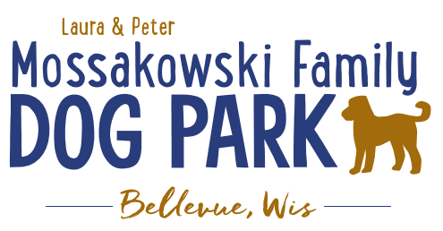

**Laura and Peter Mossakowski Family Dog Park, LTD Committee Meeting**

**Date & Location:** Thursday, October 31st @ 9:15am @ Laura Mossakowski LLC (2555 Continental Dr.; Green Bay, WI 54311)

**Meeting Began: 9:15am**

**In attendance:Jack LeDuc, Laura Mossakowski, Paul Theys, Jennie Wertel**

**VP Report:**

Approval of August Minutes:Laura Mossakowski, Paul Theys

**Treasurer Report:**

Current Balance: $75,716 +$1,616.48 $ [prev meeting: $75,670 + $2,622 est. total with Village after bills pd]

Outstanding Bills:accountant

Incoming Donations:park passes are still being sold; sign options still available, PayPal, Venmo

**Secretary Report:**

**Community Fundraising:**

Grant Writing– looking for someone to help in this department

(Ongoing Topic) Memorial fundraisers – step 1 is to know where they would be going, any thoughts?

small gardens, rocks and other structures, plaques, benches, etc.; Consider a fund raiser campaign kickoff for memorial options (bricks, benches, etc.) if location is decided

-Benches and Table Memorials can have plaque memorials added – requested minimum of $2500

-Memorial plaque on Little Free Library option, plaques on the agility equipment – starting at $500 (based on the cost of materials, size, and location)

-A few hydrants to be installed and plaques made; $2500+ Fire hydrants or memorial boulders

Small Dog Area hydrant plaque still available for sponsorship/donation – requested minimum of $2500

DNR grants - Trail Grants Due May 1 Annually

Due to costs and constrictions from the Village Budget it is unlikely that any changes will be able to happen in the coming year or two; more likely goal is 2026-2027 but any possible village contributions won’t happen until 2028 if at all

Begin to look at priority for the committee to continue to build out the master plan

* Consider doing smaller phases of the boardwalk to keep progress moving forward
* Consider pedestrian rated boardwalk initially, then expand as we are able and as we can continue to plan towards the bridge

***Important/Key goal****: 2025 is when the next Village of Bellevue CORP (Bellevue Comprehensive Outdoor Recreation Plan) will be drafted, and it will include more advancements for the Dog Park as a way to help make Grant Applications stronger and continue to be include in the Village of Allouez future plans for ongoing planning*

Look at making the project break up in phases starting with the board walk from the existing dog park to the bridge site, then look at expanding from there if budgeting allows

Difficulty getting a quote that fits the budget due to the expenses of the trail

**Old Business:**

Kiosk needs to be leveled out when able –2024 – postponed to next year

Mud holes need attention under the shelters and filling in some space by gates

Water is off for the winter – this week

Canopies coming down next week

**New Business:**

Jack was hoping there is a way to look to raise funds for lighting to allow for longer park hours, especially as it is getting darker in fall/winter seasons

Looking for thoughts on raising funds and being able to expand that

New volunteers looking to join the committee in the future to look at fundraising opportunities

Consider adding signage to the gates to ensure that only one is open at a time or a spring mechanism to help keep it in a closed position (gentle closure to stop the visual of an open gate for the dogs)

Kiosk update – need new background; consider magnet board rather than new cork board for long term use and less maintenance

Consider private bids on the concrete slabs to help with costs

**Next Meeting Dates:** Wednesday, January 8th, 2025 @ Laura Mossakowski LLC (or via zoom)

**Meeting Adjourned: 10:10a**