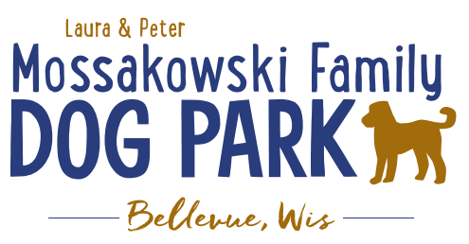

**Laura and Peter Mossakowski Family Dog Park, LTD Committee Meeting**

**Date & Location:** Wednesday, August @9:30am @ Laura Mossakowski LLC (2555 Continental Dr.; Green Bay, WI 54311)

**Meeting Began:**

**In attendance:**

**VP Report:**

Approval of June Minutes:

**Treasurer Report:**

Current Balance: $ 79436.25_ [prev meeting: $88,185 + $2,345 est. total with Village after bills pd]

Outstanding Bills:

Incoming Donations:

**Secretary Report:**

**Community Fundraising:**

Grant Writing– looking for someone to help in this department

Packers Grant Completed – Focus was on an ADA Pathway and Lighting in the Park; Expected update in fall and awards are expected to be known in November

(Ongoing Topic) Memorial fundraisers – step 1 is to know where they would be going, any thoughts?

small gardens, rocks and other structures, plaques, benches, etc.; Consider a fund raiser campaign kickoff for memorial options (bricks, benches, etc.) if location is decided

-Benches and Table Memorials can have plaque memorials added – requested minimum of $2500

-Memorial plaque on Little Free Library option, plaques on the agility equipment – starting at $500 (based on the cost of materials, size, and location)

-A few hydrants to be installed and plaques made; $2500+ Fire hydrants or memorial boulders

Small Dog Area hydrant plaque still available for sponsorship/donation – requested minimum of $2500

DNR grants - Trail Grants Due May 1 Annually

Due to costs and constrictions from the Village Budget it is unlikely that any changes will be able to happen in the coming year or two; more likely goal is 2026-2027 but any possible village contributions won’t happen until 2028 if at all

Begin to look at priority for the committee to continue to build out the master plan

* Consider doing smaller phases of the boardwalk to keep progress moving forward
* Consider pedestrian rated boardwalk initially, then expand as we are able and as we can continue to plan towards the bridge

***Important/Key goal****: 2025 is when the next Village of Bellevue CORP (Bellevue Comprehensive Outdoor Recreation Plan) will be drafted, and it will include more advancements for the Dog Parkas a way to help make Grant Applications stronger and continue to be include in the Village of Allouez future plans for ongoing planning*

QR Code and Link to be put on the website and FB page to help with getting feedback from park users

Encourage all users to add feedback – advertise on Social Media!

Look at making the project break up in phases starting with the board walk from the existing dog park to the bridge site, then look at expanding from there if budgeting allows

Difficulty getting a quote that fits the budget due to the expenses of the trail

**Old Business:**

Kiosk needs to be leveled out when able –2025

Mud holes need attention under the shelters and filling in some space by gates – some dirt to come from another project

Jack was hoping there is a way to look to raise funds for lighting to allow for longer park hours, especially as it is getting darker in fall/winter seasons

-Looking for thoughts on raising funds and being able to expand that and consider the ask in the Packers Grant

-New committee members hoping to plan some events in the coming year to help raise funds to allow for the expansion of hours, considering having a fundraising event

- Event likely postponed until 2026 due to planning

Mowing Update: Alter the mowing paths to allow grass to recover where it had higher traffic in the past

Kyle to reach out to update them on that plan; consider a higher mow cut to help reduce the high traffic as well

Consider re-seeding the walk in area and fence it off to help (Jennie to pass on name of sod option to explore costs for as well)

**New Business:**

Keep encouraging visitors to fill out the survey for the CORP

Can we have some additional weed-eating/mowing done around the benches and rocks? Some of the rocks are memorials but also a safety request to help make them more visible to running dogs with nothing else on their minds but the zoomies.

**Next Meeting Dates:** ______________ @_____Laura Mossakowski LLC (or via zoom)

**Meeting Adjourned:**