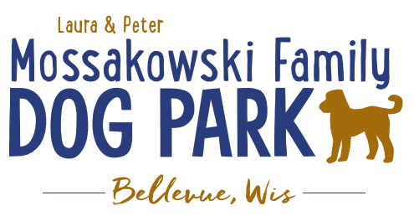
Laura and Peter Mossakowski Family Dog Park, LTD Committee Meeting

Date & Location: Friday, October 17, 10:30a@ Laura Mossakowski LLC (2555 Continental Dr.; Green Bay, WI 54311)

Meeting Began: 10:30a

In attendance: Jack Leduc; Laura Mossakowski; Paul Theys; Jennie Wertel; Kyle Casper

VP Report:
Approval of August Minutes:Paul Theys, Laura Mossakowski

Treasurer Report:
Current Balance: $79,596 + $7,801.94[prev meeting: $79,436.25 + 8,673.96 est. total with Village after bills pd]
Outstanding Bills:
Incoming Donations: Venmo and Paypal have some donations incoming; OakView Veterianry Hospital ($194)

Secretary Report:
Community Fundraising:
Grant Writing– looking for someone to help in this department
Packers Grant Completed – Focus was on an ADA Pathway and Lighting in the Park; Expected update in fall and awards are expected to be known in November

Grants and other funding needed – continue to seek DNR Grants and others, many depend on being in the Village of Bellevue 5yr CORP
Draft sent to Village Board to include the Dog Park, that needs to be approved by the Village and then that will go on to the DNR for future eligibility for those grants over the next 5 years

Old Business:
Kiosk needs to be leveled out when able –2025

Mud holes need attention under the shelters and filling in some space by gates – some dirt to come from another project; Waiting on weather to help facilitate access

New Business:
Grass/landscaping to be done around the concrete pads in the fall to try to encourage growth; consider also seeding some of the puddle areas to try to encourage re-growth of the areas (back by the Eagle Scout shelter and to the edges of the berm)

Brochures added to holder at the park to help encourage volunteers to sign up and giving info on how

Social media post about fall/Halloween pet photos

Next Meeting Dates: January 14th @ 4:30pm @Laura Mossakowski LLC (or via zoom)

Meeting Adjourned:11:00a

