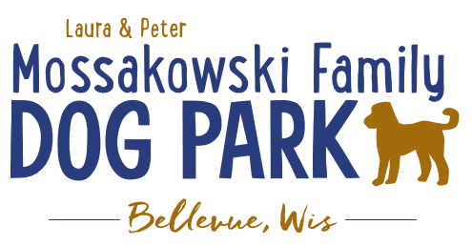
Laura and Peter Mossakowski Family Dog Park, LTD Committee Meeting

Date & Location: Friday, October 17, 10:30a@ Laura Mossakowski LLC (2555 Continental Dr.; Green Bay, WI 54311)

Meeting Began:

In attendance:

VP Report:
Approval of August Minutes:

Treasurer Report:
Current Balance: $___________[prev meeting: $79,436.25 + 8,673.96 est. total with Village after bills pd]
Outstanding Bills:
Incoming Donations: Venmo and Paypal have some donations incoming; OakView Veterianry Hospital

Secretary Report:
Community Fundraising:
Grant Writing– looking for someone to help in this department
Packers Grant Completed – Focus was on an ADA Pathway and Lighting in the Park; Expected update in fall and awards are expected to be known in November

Grants and other funding needed – continue to seek DNR Grants and others, many depend on being in the Village of Bellevue 5yr CORP

Old Business:
Kiosk needs to be leveled out when able –2025

Mud holes need attention under the shelters and filling in some space by gates – some dirt to come from another project

New Business:
Grass/landscaping to be done around the concrete pads in the fall to try to encourage growth; consider also seeding some of the puddle areas to try to encourage re-growth of the areas (back by the Eagle Scout shelter and to the edges of the berm)

Next Meeting Dates: ________________ @ ________Laura Mossakowski LLC (or via zoom)

Meeting Adjourned:

