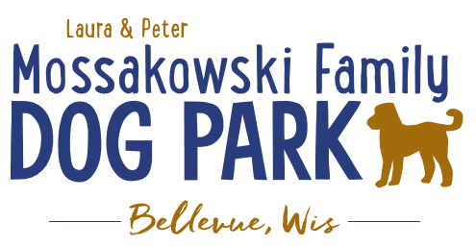
Board Meeting Agenda
January 14, 2026

Meeting Began:
Attendance:

Officer Election/Re-election – Motion to re-elect the following positions President, Vice President,&Treasurer
All in favor:
Opposed:

Current Board Members:
Laura Mossakowski – President
Jennie Wertel – Vice President
Paul Theys – Treasurer

Review of 2024 Meeting Minutes including prior January 14, 2026 meeting
Approved:
Opposed:

Review bylaws and confirm edits: no edits at this time
Approved:
Opposed:

2026 Focus:
Phase II Planning –possible addition of the entry way structures; looking forward to the bridgeand trails

Improvement Projects – install the in park lighting and ADA pathway

Fundraising Efforts – continue to raise funds to build out the master plan for the park

Committee Building – continue to build on the size of the committee in order to be able to continue to offer more dog friendly events

Increase Social Media push for events and volunteers – goal is to increase people to come to events and awareness of park and increase the number of volunteers

Ensure we are included in the Village of Bellevue CORP to help make grant applications more successful

Meeting Adjourned:

