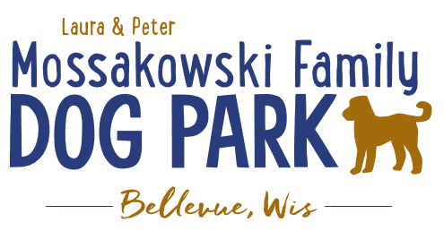
Laura and Peter Mossakowski Family Dog Park, LTD Committee Meeting

Date & Location: Wednesday, January 14th, 2026 @ 4:30pm@ Laura Mossakowski LLC (2555 Continental Dr.; Green Bay, WI 54311)

Meeting Began:

In attendance:

VP Report:
Approval of October Minutes:

Treasurer Report:
Current Balance: $_______________[prev meeting: $79,596 + $7,801.94 est. total with Village after bills pd]
Outstanding Bills:
Incoming Donations:Grainger Donation, Packers Grant

Secretary Report:
Community Fundraising:
Grant Writing–Interest from Shanna to help with this

Grants and other funding needed – continue to seek DNR Grants and others, many depend on being in the Village of Bellevue 5yr CORP
Draft sent to Village Board to include the Dog Park, that needs to be approved by the Village and then that will go on to the DNR for future eligibility for those grants over the next 5 years

Old Business:
Kiosk needs to be leveled out when able – 2026

Packers Grant was secured, $3,000
Begin to plan what the project will look like for the lighting and ADA pathway
How many lights? How much of the park to be covered? Lighting on pathway as well?

ADA pathway estimate includes what appears to be a very large budget for restoration, is there a way that the Parks team can do that to help save the $10,000?

New Business:

Next Meeting Dates: ___________________________ @Laura Mossakowski LLC (or via zoom)

Meeting Adjourned:

