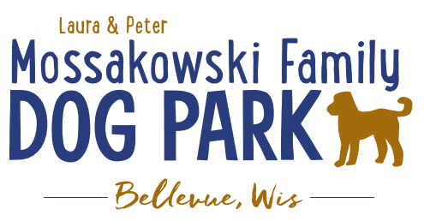
Laura and Peter Mossakowski Family Dog Park, LTD Committee Meeting

Date & Location: Wednesday, February 25th, 2026at 4:30pmat Laura Mossakowski LLC (2555 Continental Dr; Green Bay, WI 54311)

Meeting Began:
In attendance:

VP Report:Approval of January Minutes:

Treasurer Report:Current Balance: $93,023.84 + $1,652.31 net village balance roughly [per previous mtg: $85,443 + $4,000 est. total with Village after bills pd] Total $94676.15
Outstanding Bills: Web site hosting $215.81 + Domain Registration $23.00= $238.81
Incoming Donations: Laura/ Pete $7500

Secretary Report:

Community Fundraising:

*Paul – Update on private group looking to donate with sponsorship

*Grant Writing–working on grants for solar lights & pathways
Packers Grant for 2026 is due April 1, to be eligible the work from the previous grant must be completed

*Grants and other funding needed – continue to seek DNR Grants and others, many depend on being in the Village of
Bellevue 5yr CORP. Draft sent to Village Board to include the Dog Park, that needs to be approved by the Village and then that will go on to the DNR for future eligibility for those grants over the next 5 years

Old Business:
*Kiosk needs to be leveled out when able – 2026– likely in conjunction with build out this spring/summer

*Packers Grant was secured for $3,000 (already in DP acct) & we are not eligible until this project is done & 2026 is a new animal grant cycle (due to packers changing the cycle), & then it’ll be on a 4 year rotation after that, so may not be eligible again until 2030ish.
-Begin to plan what the project will look like for the lighting and ADA pathway. How many lights? How much of the park to be covered? 6-7 at least
-Lighting on pathway as well?yes
-ADA pathway estimate includes what appears to be a very large budget for restoration, is there a way that the Parks team can do that to help save the $10,000?-Yes! Could decrease the cost to $18K.
-Using Asphalt or Concrete? Kyle’s quotes were for asphalt & Mark was thinking concrete - maintenance free comparable to asphalt, but more costly than asphalt. Send Mark estimates to review per his expertise.

New Business: None

Next Meeting Date:______________ at _______ @Laura Mossakowski LLC (or via zoom)
Meeting Adjourned:

